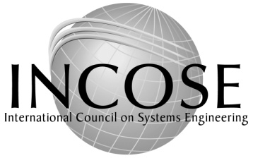
International Council on System Engineering
7670 Opportunity Rd #220 • San Diego, CA 92111
Tel: (800) 366-1164 (US & Canada)
Fax: (858)541-1728 • Email: carrie.lopez@incose.org
Website: www.incose.org

INCOSE Certification Fees

 | List | Member | Qty | Total (USD)
ASEP Certification Fee (Must be an INCOSE Member) |  | $150.00 |  | $
CSEP Certification Fee Non-member | $400.00
CSEP Certification Fee Member |  | $300.00 |  | $
ASEP-CSEP Transition Fee |  | $200.00
ESEP Certification Fee (Must be an INCOSE Member) |  | $550.00 |  | $
SEP Renewal Fee | $150.00 | $100.00 |  | $
SEP Acq Renewal Fee | $150.00 | $125.00
SEP Renewal late Fee (please contact office)

_______________________________________________________________________________________________
Name Member Number

______________________________________________________________________________________________________________________
Mailing Address

_______________________________________________________________________________________________
Mailing Address

_______________________________________________________________________________________________
Zone/City Code City State/Prov Zip Country

_______________________________________________________________________________________________
Office Phone Office Fax

_______________________________________________________________________________________________
Email Home Phone (optional)

Payment Enclosed ___Bank Check _____Money Order (payee is ‘INCOSE”)
Credit Card – Visa, MasterCard or American Express (no other cards accepted)

______________________________________________________________________________________
Card Number Expiration Date CVV

_______________________________________________________________________________________________
Name as it appears on card Signature

