INCOSE Chicagoland Audience Respondent Survey
Feb. 18. 2016
Age: __ 20 – 29 __ 30 – 39 __ 40 – 49 __ 50 – 59 __ 60 – 69 ____ 70 - 79
Career Work Experience: _______ Total Years _________ Years as an SE
Current Job Title: ____________________________ Industry: ________________________________

Education | Degree(s) | Field of Study | Institution
Undergrad
Grad
Instructor(s) Qualifications: ___ Academic __ Industry Practitioner _____ Both
INCOSE Certification: ______ CSEP (Year) ______ ASEP (Year) ______ ESEP (Year)

SE Courses? | Yes | No
Undergraduate Level
Graduate Level
SE Certificate

 | Primary textbook used for course(s)
Used in Course(s)?
Please check
Text | 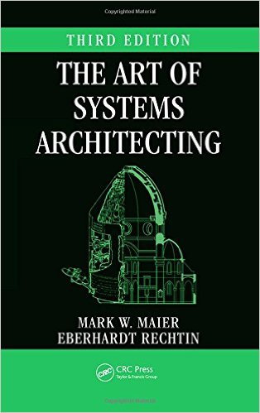 | 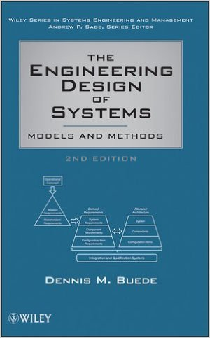 | 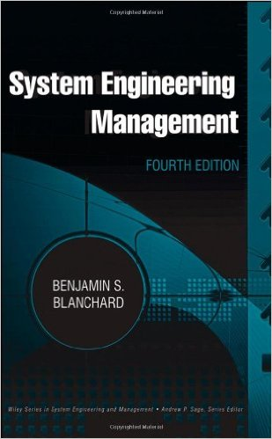 | 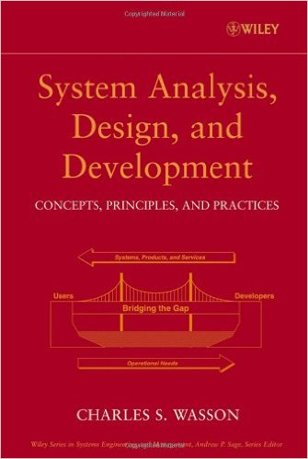 | 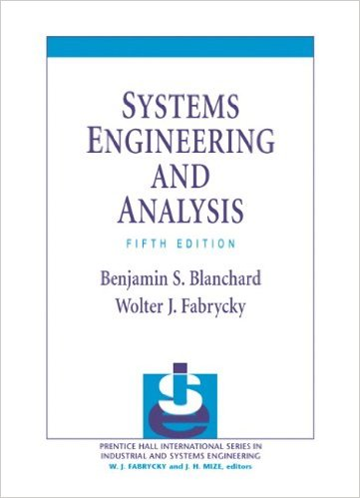 | 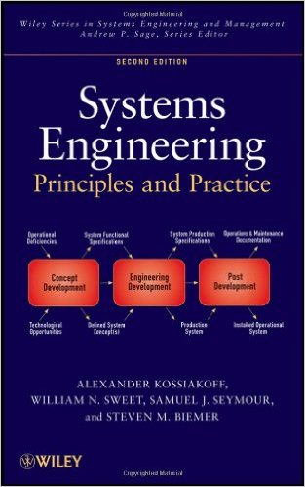
Author | Rechtin & Maier | Buede | Blanchard | Wasson | Blanchard & Fabrycky | Kossiakoff & Sweet
Your SE Value Rating
1 = Low
10 = High
Other texts & value rating (1 = Low, 10 = High)? Please specify

(Over)
 | Pros | Cons
I hereby grant permission for Wasson Strategics to compile my survey inputs into summary results and comments. _________________________ (Initials or mark)

