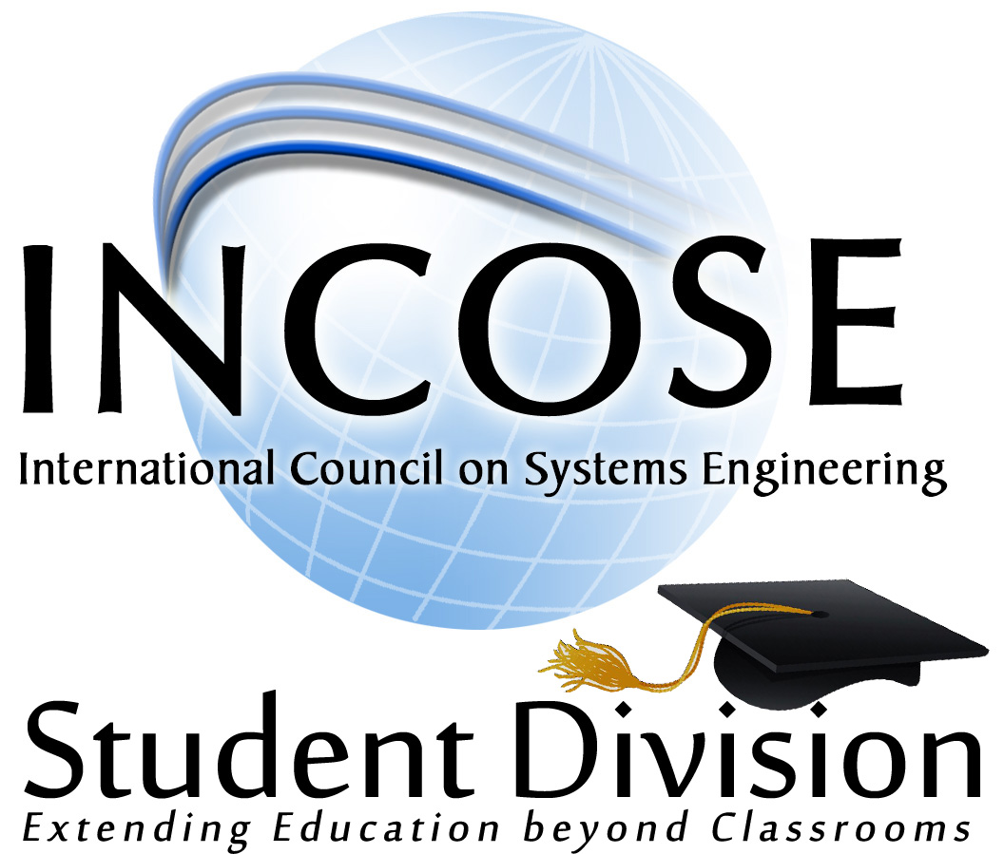

student division

Development Guide

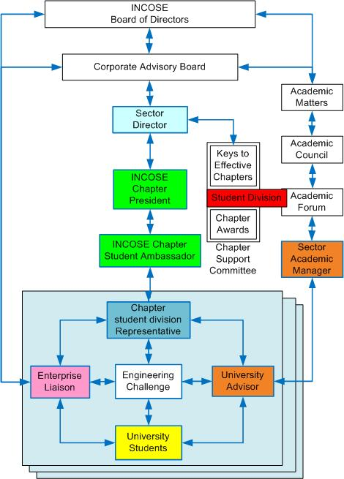
The International Council on Systems Engineering (INCOSE) is a not-for-profit organization whos’ focus is to advocate the science and application of Systems Engineering across all industrial, commercial, and governemental domains. The importance of new research and membership in the organization has been recognized as orginating within the academic environment. This recognition has led to the creation of the Student Division program to advocate systems engineering within the academia and provide a means, and oportunity, for students to present their research. The Student Division stucture illustrates the relation of the Student Division within INCOSE as part of the Academic Matters and the Chapter Support Committee.

This Development Guide addresses several directions which collectively identifies considerations for the development of a student division.
A ‘student division’ is an ‘engineering club’ at the respective university under the combined governance of the university and INCOSE. The heart of the Student Division program lies within the Mentoring Network (highlighted in blue) created by the stakeholders of the 4-Way Benefit Model at the university. The architecture, along with the roles and expectations of these stakeholders are detailed in the ‘Student Division Program Architecture’ which can be found at: http://www.incose.org/chapters/studentdivisions.aspx

The key to the formation and operation of a student division centers on the Students who recognize the value of developing a professional network in a recognized field, a University Advisor who advocates systems engineering and the values and opportunities provides by INCOSE, the Student Division Representative from the sponsoring INCOSE Chapter who encourages the thransfer of knowledge as a professional systems engineer and the contributions of INCOSE, and the Enterprise Liaison who endorses the acheivements and success of the students and the association with the enterprise. These four stakeholders provide the spark to the formation and execution of a student division.

Where to start?
Begin by identifying a University Advisor and student(s) who advocate an interest in developing a student division. Identify the governance of the university on the requirements to have an ‘engineering club’ on campus. Contact an INCOSE chapter to request sponsorship and a representative, who may also be an Enterprise Representative. Evaluate the merits of developing an INCOSE student division and the merits of:
- The advisor becoming a CAB member, Academic Forum Members, or as an individual member. See the INCOSE website for information on membership at: http://www.incose.org/membership/membershiptypes.aspx
- Advocate the value of a student division across the student body to determine the interest level to establish a student division.
- Establish support through the sponsoring INCOSE chapter.
- Develop a student division charter and elect student division officers. Use the ‘student division constitution’ template located on the INCOSE student division website as a guide. The charter is to be approved by the student division officers, the advisor, the INCOSE chapter student division representative, and the enterprise liaison representative (optional).
- Ratify the student academic load according to the INCOSE website with submittal of their application, proof of academic load, and student membership fees.
- Identify the ‘executive committee’ for the student division. These are the 4-Way Model Stakeholders plus individuals with key supporting roles for the student division. Develop a point of contact list (POC) of the executive committee members.

Develop the Value Proposition
Each student division is unique with Value Propositions (what is important) for the health and sustainment of a student division. These value propositions should be identified and documented by the student division Secretary. The executive committee is to then convert these into success metrics. These metrics are to be evaluated annually by the executive committee for accomplishments and modification as needed. These are the measurements of the health and sustainment of the student division.

Student Division Website
The executive committee should determine the content for a student division website to communicate the creation, POC information, meeting and events, and means to advocate the student division across the campus to all departments and students. This website should be hosted according to university governance with a link provided to INCOSE central office for inclusion on the INCOSE student division website.

Engineering Challenge
An Engineering Challenge is at the center of the mentoring network. This is the catalyst for practicing engineers from supporting enterprise to collaborate with students and universities in the development of student selected projects. This challenge can represent a ‘Capstone’ project or a practical engineering experience to extend the engineering experience beyond the classroom. The engineering challenge is detailed in the ‘INCOSE Engineering Challenge’ on the INCOSE student division website where selection, criteria, and awards are described. This collaboration also provides the opportunity for enterprise representatives to not only provide a real-world challenge to the students, but also opportunities for enterprise to observe students for a prospective future.

IUSE Campaigns
Another means to achieve student division success is through the use of an IUSE Campaign. This is a collaborative conference amongst the 4-Way Benefit Model Stakeholders to advocate the achievements and exposure of all the stakeholders for mutual benefit. This would include opportunities to witness the products, challenges, and opportunities provided by the enterprise but also the opportunity to observe the characteristics of the students. Universities gain further insight into the engineering trends required by the enterprise.

Reporting
The executive committee, through the INCOSE student division representative, has the responsibility to report the following information to the Assistant Director of the Student Division:
- The student division ‘constitution’.
- POC information for the student division executive committee
- A list of the student members, both INCOSE members and non-members
- A list of Value Propositions and Success metrics developed, reviewed, and those adjusted.
- IUSE Campaign events planed, executed, and documented.
- Other information relative to the success of the student division.

