RSVP to Membership chair Bradley Biehn at Bradley.Biehn@nasa.gov if you plan to attend so that we can estimate headcount for food orders.
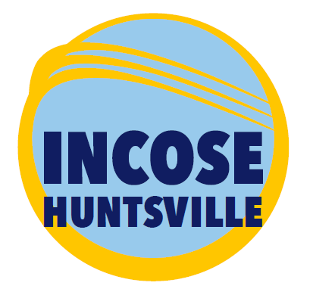 |  | 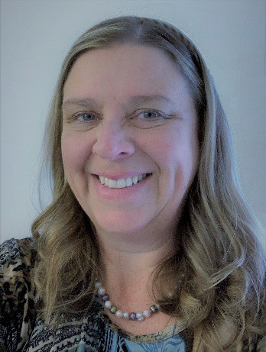
Susan Askew, PE, CSEP-Acq
Black Swan Rising (BSRi)
Thursday, October 21, 2021 | 5:30 pm
UAH – Wilson Hall – Room 209
Masks Required at UAH
==== PRECIS ====
Option to attend via ZOOM…details provide below

Agenda
Time | Meeting Topic | Presenter
5:30 – 6:00 PM  5:45 PM | Meet-and-Greet Meal Time  $5 honor box donation – Members only
6:00 – 6:15 PM | INCOSE Announcements  - Chapter  - Membership Report  - Finance Report  - Upcoming Events & Conferences  - UAH Student Division Status  - Request for Board 2022 Nominations  - Corporate Sponsorship Program Proposal  - Circle Award 2021 Status | Paul Sullivan  Tony Lindeman
6:15 – 7:00 PM | PRECIS | Susan Askew
7:15 – 7:45 PM | INCOSE – HRC Board Meeting  • Recognition Letter Status  • October 2021 Board Recruitment & Elections  - Corporate Sponsorship Program Proposal  • HATS Professional of the Year nomination | Paul Sullivan  Tony Lindeman

Abstract
You CAN be the Center of the Universe and survive!!
Join us for a discussion on how to increase your value to your employer and learn to be indispensable, important, promotable… and do it sustainably without sacrificing all other things in your life.

Are you a linchpin or bottleneck?
Leah Crawford of Higher Eschelon defines a linchpin as the person in your organization who is indispensable, leads with or without a title, and creates so much value they alone are worth 4-5 more typical employees. Webster defines bottleneck as a narrow route or a point of traffic congestion. A bottleneck is also someone or something that retards or halts free movement and progress – an impasse.
Which are you? How can you tell the difference, especially when it’s YOU?
As we go through our careers, working towards more responsibility, promotions, more “important” work, we will take on new projects and positions. At some point, you may feel like the whole word depends on you and would come to a screeching halt if you took off a day to relax. So how can you survive when you’re the center of everything? Is it even possible to be a key contributing, important, employee and still get a day off? How do you let go of “important work” and still gain more value and grow in your career?
How can you help others who are stuck and enable/encourage them to choose being a linchpin instead of choosing bottleneck?
Come participate in the discussion! We will talk about these questions and see what corporate advisors AND OUR PEERS have to say on these questions. We can exchange ideas on what works in OUR work environments as Systems Engineers and technical leaders. And maybe we will even learn how we can be very important to our employers without becoming absent in the rest of our lives.

Speaker Bio
Ms. Susan Askew is the Chief Technical Officer and Co-Owner of Black Swans Rising (BSRi), a professional services and consulting business in Huntsville, AL, focused on serving commercial and government organizations by optimizing business processes and providing program management (PM) and systems engineering (SE) advisory services – bringing the best of SE and PM together for innovative technical leadership solutions. In her role as Chief Technical Officer, Ms. Askew is responsible for leading the BSRi Technical Team in Systems Engineering and Technical Management projects.

Ms. Askew has over 28 years of experience as a DoD civilian and defense contractor, having worked for the US Air Force, the US Army, the Missile Defense Agency, and commercial businesses as an Electronics and General Engineer. Ms. Askew taught Systems Engineering and Test & Evaluation courses as a Professor of Systems Engineering Management for the Defense Acquisition University (South Region). Prior to joining DAU, she served as the Chief Systems Engineer for Complex Medium and Long Range Targets for the Missile Defense Agency. She has supported test range activities and test asset development and operations across the full product lifecycle for the US Air Force and Army. She has owned her own business in the US and overseas, and served as Engineering Supervisor for multiple organizations.

Additionally, Ms. Askew is an Adjunct Professor for Auburn University and with Calhoun Community College’s new Systems Engineering Technologist program (1st of its kind in the nation). In both of these roles, she contributes DoD perspectives as well as government and industry best practices to new curriculum and classroom instruction for Systems Engineering, Systems Engineering Technology, and Engineering Management undergraduate and graduate students.

Ms. Askew received her Bachelor’s of Electrical Engineering degree in 1987 from Auburn University and a Master’s of Science in Management (International Business) degree in 2004 from Troy State. She has been a member of the DoD Acquisition Corps since 2009, and holds DAWIA Level 3 certifications in Engineering, Test & Evaluation, and Program Management career fields. She is a licensed Professional Engineer in Alabama and a Certified Systems Engineering Professional – Acquisition (CSEP-Acq). Ms. Askew is active supporting STEM education activities in her community, and in Auburn University’s 100+ Women Strong program as a member of the Retention Committee and engineering student Mentor. Since 2020, Ms. Askew is a quarterly contributor to a Huntsville community magazine on professional and personal effectiveness articles.

Ms. Askew’s philosophy is to always start with the end in mind. Her passion is applying critical analytical thinking to everyday challenges to develop collaborative and innovative solutions across all realms of business, education, and life.
ZOOM Meeting Log-in Information

Join Zoom Meeting
https://incose-org.zoom.us/j/91413320588?pwd=bWZRZDZuRVdVV1FSZUZzN3FsSEN1UT09

Meeting ID: 914 1332 0588
Passcode: 596086

877 853 5257 US Toll-free
888 475 4499 US Toll-free

Meeting ID: 914 1332 0588
Passcode: 596086

Find your local number: https://incose-org.zoom.us/u/adpZh1o4jb

Join by Skype for Business
https://incose-org.zoom.us/skype/91413320588

Driving Directions to Meeting
Traveling East on I-565:
From I-565, traveling East, take the Sparkman/Bob Wallace/Space Center exit. Turn left onto Sparkman Drive. Travel North on Sparkman Drive across I-565 and through the first traffic light. Merge into the far right lane traveling to the second traffic light. That lane must turn right onto the UAH campus.
On the campus, follow the road a short block to a fork and bear left. You will quickly come to a Stop sign and should bear left again. Follow this road through the round-about taking the second exit, under the Holmes Street Bridge and through another Stop sign.
At the Stop sign, you will be in front of the Business Administration Building to the right. The next building is Wilson Hall. It is a large, brown brick building, which is contemporary in style with broad bands of white trim. You may park in any of the available parking places that serve the Business Administration Building, Wilson Hall, the student dorm, and the Bevill Center.
Traveling West on I-565:
From I-565, traveling West, take the Sparkman/Bob Wallace/Space Center exit. Turn right onto Sparkman Drive. Travel North on Sparkman Drive across I-565 and through the first traffic light. Merge into the far right lane traveling to the second traffic light. That lane must turn right onto the UAH campus.
On the campus, follow the road a short block to a fork and bear left. You will quickly come to a Stop sign and should bear left again. Follow this road through the roundabout taking the second exit, under the Holmes Street Bridge, and through another Stop sign.
At the Stop sign, you will be in front of the Business Administration Building to the right. The next building is Wilson Hall. It is a large, brown brick building, which is contemporary in style with broad bands of white trim. You may park in any of the available parking places that serve the Business Administration Building, Wilson Hall, the student dorm, and the Bevill Center.
Parking
Important Parking Restrictions:
- Park ONLY in the Commuter Area parking lot directly in front of Wilson Hall; those parking in other areas may be subject to parking tickets
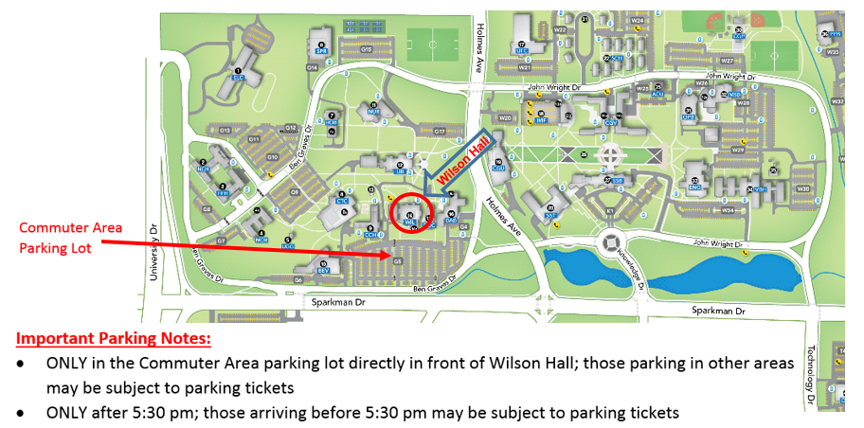
- Park ONLY after 5:30 pm; those arriving before 5:30 pm may be subject to parking tickets

Huntsville – HRC LinkedIn Group
Sign up for the Huntsville INCOSE Chapter LinkedIn group at:
http://www.linkedin.com/groups?gid=1796955

RSVP to Membership chair Bradley Biehn at Bradley.Biehn@nasa.gov if you plan to attend so that we can estimate headcount for food orders.

