RSVP to Membership chair Bradley Biehn at Bradley.Biehn@nasa.gov if you plan to attend so that we can estimate headcount for food orders.

 | 

Richard Steinberg
Northrop Grumman Space Systems
Thursday, January 20, 2022 | 5:30 pm
UAH – Wilson Hall – Room 209
or
Virtually via Zoom – details below
Masks Required at UAH
The Economic Benefits of Human Performance Models in Systems Engineering

RSVP to Membership chair Bradley Biehn at Bradley.Biehn@nasa.gov if you plan to attend so that we can estimate headcount for food orders.

Agenda
Time | Meeting Topic | Presenter
5:30 – 6:00 PM | Meet-and-Greet Meal Time  $5 honor box donation – Members only
6:00 – 6:15 PM | INCOSE Announcements  - Chapter  - Membership Report  - Finance Report  - Upcoming Events & Conferences  - INCOSE – HRC Student Division Status  - Corporate Sponsorship Program Status  - Circle Award 2022 Status | Tony Lindeman
6:15 – 7:00 PM | The Economic Benefits of Human Performance Models in Systems Engineering | Richard Steinberg

Featured Topic
Title: The Economic Benefits of Human Performance Models in Systems Engineering
Speaker: Richard Steinberg, Northrop Grumman Space Systems

Abstract
Human performance modeling (HPM) is a method of quantifying human behavior, cognition, physical performance, and processes used for the development of systems designed for optimal user experience and interaction (Seibok and Wickens, 2013). Human Performance Models (HPMs) are an effective tool for Model Based Systems Engineering (MBSE) (Steinberg et al, 2017), with high economic benefit. Human Engineering practitioners use HPMs to define crew design requirements including the number of operators needed, the benefits of automation, and distribution of member task responsibilities required to operate a system. The application of HPMs throughout the development process helps to influence the system design by integrating with MBSE processes and informing many aspects of system definition and development including performance trades of algorithms, hardware, command and control functions, automation, and the need for situation awareness to monitor the system. In addition to these design benefits, HPMs save development costs and for a described case study reduced costs $4.3M demonstrating the economic benefits for systems engineering. This paper will outline the HPM process for a Command and Control (C2) system.

Speaker Biography
Dick Steinberg is a User Experience Engineer for Northrop Grumman designing Command and Control Displays. He has a mechanical engineering degree from Auburn, the Naval Post Graduate School HSI Certification, and the Human Factors International User Experience Certification. He has 36 years of experience in industry, and two patents in user experience inventions and is a former chapter president of our local Human Factors and Engineering Society chapter. Dick says what qualifies him most to give this talk is the fact that he volunteered pre-COVID to tutor second grade math at a local title 1 elementary school. “If you can communicate then benefits of math to second graders, you can learn to communicate anything.” Today he speaks from his experience in Human performance modeling, an important element of Model Based Systems Engineering methods as presented at the INCOSE conference in November 2021.

Zoom Information
Join Zoom Meeting
https://incose-org.zoom.us/j/91413320588?pwd=bWZRZDZuRVdVV1FSZUZzN3FsSEN1UT09

Meeting ID: 914 1332 0588
Passcode: 596086

US Toll-free: 877-853-5257
US Toll-free: 888-475-4499
Or find your local number: https://incose-org.zoom.us/u/adpZh1o4jb

Join Zoom meeting via Skype for Business
https://incose-org.zoom.us/skype/91413320588

Driving Directions
Traveling East on I-565
From I-565, traveling East, take the Sparkman/Bob Wallace/Space Center exit. Turn left onto Sparkman Drive. Travel North on Sparkman Drive across I-565 and through the first traffic light. Merge into the far right lane traveling to the second traffic light. That lane must turn right onto the UAH campus.
On the campus, follow the road a short block to a fork and bear left. You will quickly come to a Stop sign and should bear left again. Follow this road through the round-about taking the second exit, under the Holmes Street Bridge and through another Stop sign.
At the Stop sign, you will be in front of the Business Administration Building to the right. The next building is Wilson Hall. It is a large, brown brick building, which is contemporary in style with broad bands of white trim. You may park in any of the available parking places that serve the Business Administration Building, Wilson Hall, the student dorm, and the Bevill Center.
Traveling West on I-565
From I-565, traveling West, take the Sparkman/Bob Wallace/Space Center exit. Turn right onto Sparkman Drive. Travel North on Sparkman Drive across I-565 and through the first traffic light. Merge into the far right lane traveling to the second traffic light. That lane must turn right onto the UAH campus.
On the campus, follow the road a short block to a fork and bear left. You will quickly come to a Stop sign and should bear left again. Follow this road through the roundabout taking the second exit, under the Holmes Street Bridge, and through another Stop sign.
At the Stop sign, you will be in front of the Business Administration Building to the right. The next building is Wilson Hall. It is a large, brown brick building, which is contemporary in style with broad bands of white trim. You may park in any of the available parking places that serve the Business Administration Building, Wilson Hall, the student dorm, and the Bevill Center.
Parking
Important Parking Restrictions:
- Park ONLY in the Commuter Area parking lot directly in front of Wilson Hall; those parking in other areas may be subject to parking tickets
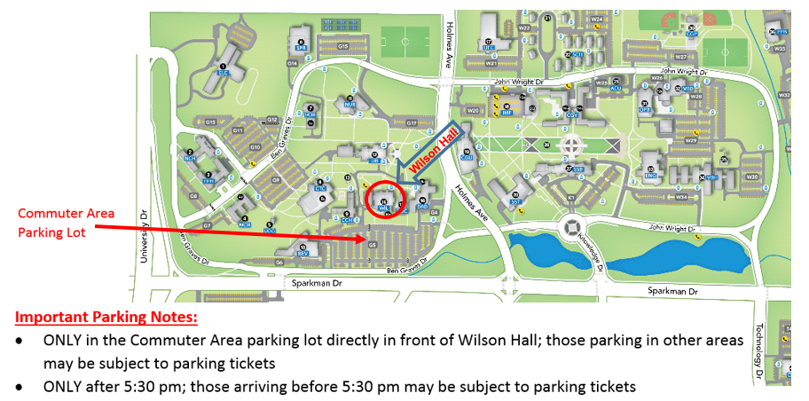
- Park ONLY after 5:30 pm; those arriving before 5:30 pm may be subject to parking tickets

Huntsville – HRC LinkedIn Group
Sign up for the Huntsville INCOSE Chapter LinkedIn group at:
http://www.linkedin.com/groups?gid=1796955

RSVP to Membership chair Bradley Biehn at Bradley.Biehn@nasa.gov if you plan to attend so that we can estimate headcount for food orders.

