RSVP to Membership chair Bradley Biehn at Bradley.Biehn@nasa.gov if you plan to attend so that we can estimate headcount for food orders.
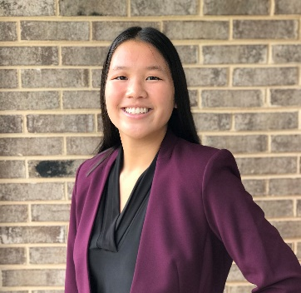
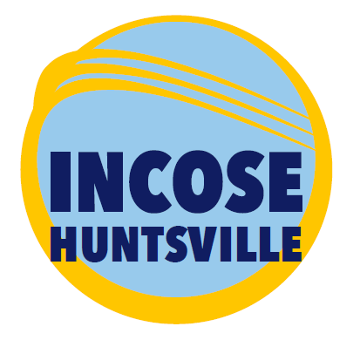

Perceived Value of MBSE
Kelly Campo & Thomas Teper
University of Alabama in Huntsville (UAH)
Thursday, February 17, 2022 | 5:30 pm CST
UAH – Wilson Hall – Room 209
Masks Required at UAH
Option to attend via ZOOM…details provide below

Agenda
Time | Meeting Topic | Presenter
5:30 – 6:00 PM | Meet-and-Greet Meal Time  $5 honor box donation – Members only
5:45 PM | Zoom Meeting started
6:00 – 6:10 PM | INCOSE Announcements  - Chapter  - Membership Report  - Finance Report  - Upcoming Events & Conferences  - INCOSE – HRC Student Division Status  - Corporate Sponsorship Program Status  - Circle Award 2022 Status | Tony Lindeman
6:10 – 6:25 PM | INCOSE Technical Leadership Institute | Don Gelosh
6:25 – 7:15 PM | Perceived Value of MBSE | Kelly Campo  Thomas Teper

Abstract
Although Model-Based Systems Engineering is quickly becoming adopted in Systems Engineering, there have not been many studies evaluating literature to determine the perceived value of implementing Model-Based Systems Engineering. This research first identifies and discusses previous studies on the justification or rejection of Model-Based Systems Engineering. This research primarily investigates how the Systems Engineering community perceives the value of Model-Based Systems Engineering by coding and analyzing positive and negative descriptions of Model-Based Systems Engineering, perceived benefits and drawbacks of implementing Model-Based Systems Engineering, and the evidence and metrics used to substantiate and measure each claim about Model-Based Systems Engineering. From 60 academic sources, this study collected and coded over 2 900 claims on Model-Based Systems Engineering. Our findings determine the most positive attributes of Model-Based Systems Engineering to be Verification & Validation Capability, Consistency, Reasoning, and Risk & Error Manageability, while the most negative attributes were Approach Understandability, Acceptability, Familiarity, and Approach Complexity. The most-stated benefits were Reduced Time, Better Communication/Information Sharing, Reduced Costs, and Better Analysis Capability. The most claimed drawbacks were Increased Costs, Increased Time, Increased Effort, and Worsened Capability. A large share of claims (47%) about Model-Based Systems Engineering were based on author opinions. Most claims (86%) were not substantiated by a metric. From this data, we aim to foster an understanding of the perceived value of Model-Based Systems Engineering in the Systems Engineering community that practitioners can use to conceptualize the value of Model-Based Systems Engineering in their own applications.

Speaker Biography

Kelly Campo
Kelly Campo is a sophomore majoring in Industrial and Systems Engineering at the University of Alabama in Huntsville. After completing her bachelor’s degree in 2024, she plans to pursue a master’s degree. As an undergraduate research assistant with the Mesmer Research Group, she is currently researching model-based systems engineering.

Thomas Teper
Thomas Teper is a sophomore undergraduate student in the Mechanical and Aerospace Engineering program at the University of Alabama in Huntsville. He is working toward a bachelor’s degree in Aerospace Engineering, with the intention of completing a master’s degree in the future, and a minor in Computer Science. He currently works as an undergraduate research assistant, focusing on model-based systems engineering.

ZOOM Meeting Log-in Information

Join Zoom Meeting
https://incose-org.zoom.us/j/91413320588?pwd=bWZRZDZuRVdVV1FSZUZzN3FsSEN1UT09

Meeting ID: 914 1332 0588
Passcode: 596086

877 853 5257 US Toll-free
888 475 4499 US Toll-free

Meeting ID: 914 1332 0588
Passcode: 596086

Find your local number: https://incose-org.zoom.us/u/adpZh1o4jb

Join by Skype for Business
https://incose-org.zoom.us/skype/91413320588

Driving Directions to Meeting
Traveling East on I-565:
From I-565, traveling East, take the Sparkman/Bob Wallace/Space Center exit. Turn left onto Sparkman Drive. Travel North on Sparkman Drive across I-565 and through the first traffic light. Merge into the far right lane traveling to the second traffic light. That lane must turn right onto the UAH campus.
On the campus, follow the road a short block to a fork and bear left. You will quickly come to a Stop sign and should bear left again. Follow this road through the round-about taking the second exit, under the Holmes Street Bridge and through another Stop sign.
At the Stop sign, you will be in front of the Business Administration Building to the right. The next building is Wilson Hall. It is a large, brown brick building, which is contemporary in style with broad bands of white trim. You may park in any of the available parking places that serve the Business Administration Building, Wilson Hall, the student dorm, and the Bevill Center.
Traveling West on I-565:
From I-565, traveling West, take the Sparkman/Bob Wallace/Space Center exit. Turn right onto Sparkman Drive. Travel North on Sparkman Drive across I-565 and through the first traffic light. Merge into the far right lane traveling to the second traffic light. That lane must turn right onto the UAH campus.
On the campus, follow the road a short block to a fork and bear left. You will quickly come to a Stop sign and should bear left again. Follow this road through the roundabout taking the second exit, under the Holmes Street Bridge, and through another Stop sign.
At the Stop sign, you will be in front of the Business Administration Building to the right. The next building is Wilson Hall. It is a large, brown brick building, which is contemporary in style with broad bands of white trim. You may park in any of the available parking places that serve the Business Administration Building, Wilson Hall, the student dorm, and the Bevill Center.
Parking
Important Parking Restrictions:
- Park ONLY in the Commuter Area parking lot directly in front of Wilson Hall; those parking in other areas may be subject to parking tickets
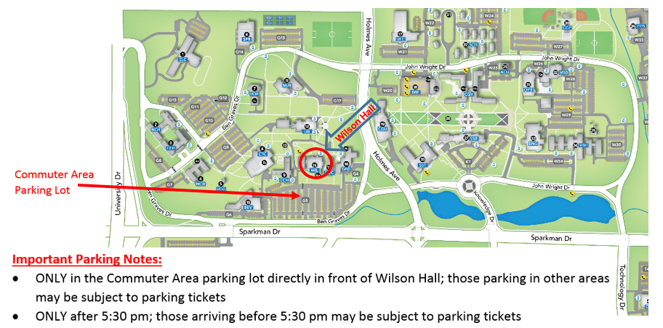
- Park ONLY after 5:30 pm; those arriving before 5:30 pm may be subject to parking tickets

Huntsville – HRC LinkedIn Group
Sign up for the Huntsville INCOSE Chapter LinkedIn group at:
http://www.linkedin.com/groups?gid=1796955

RSVP to Membership chair Bradley Biehn at Bradley.Biehn@nasa.gov if you plan to attend so that we can estimate headcount for food orders.

