# **2024 Slate for INCOSE Enchantment Chapter Leadership**

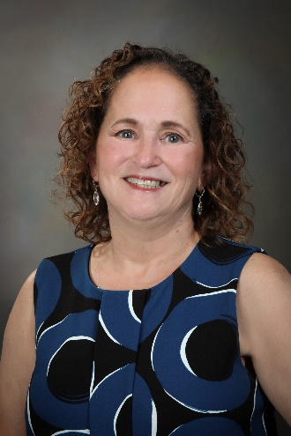

### **Past President: Cheryl Bolstad (not electable position)**

### (cheryl.bolstad@incose.net) Dr. Cheryl Bolstad is a Principal Systems Research and Analysis Engineer for the Human Factors department at Sandia National Laboratories in Albuquerque, NM. Dr. Bolstad is a Fellow of the Human Factors and Ergonomics Society and Certified Professional Ergonomist. She has a Ph.D. in Psychology specializing in cognition and human factors from North Carolina State University. Dr. Bolstad has over 30 years of experience working with the Department of Defense and within the commercial sector. She has worked extensively in situation awareness (SA) research, human automation integration, user interface design, team training and performance. Currently Dr. Bolstad is on the board of directors for a regional chapter of INCOSE, the International Society of System Engineers, and on the Technical Program Committee for the Human Factors and Ergonomics Society.

### **President: Jose Parga (not electable position)**

(jose.parga@incose.net) Dr. Jose Parga is a Research and Development Engineer focusing on Advanced Systems Development at Los Alamos National Laboratory. He has a Ph.D., M.S., and B.S. in Mechanical Engineering with a focus in Nuclear Engineering from The University of Texas at Austin. Dr. Parga has experience in Requirements Engineering, Decision Analysis, Systems Integration, Verification and Validation, and System Operation. Dr. Parga has previous experience working at production agencies while at LANL and Kansas City National Security Campus – New Mexico Operations. He is currently working on integrating Model Based Systems Engineering for future systems safety and hazard analysis at LANL.

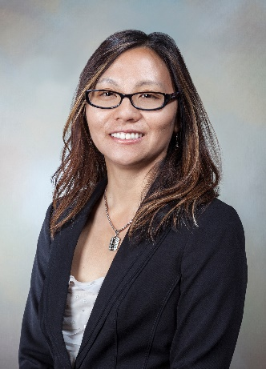**Vice-President: Amy Moy**

Amy graduated with a B.S. in Chemical Engineering from Cornell University and an M.S. in Chemical Engineering from the University of New Mexico. She is a certified Lean Six Sigma Master Black Belt, senior causal analyst, and Project Management Professional. She has over 26 years of management and engineering experience. She has held positions in research and development, design and production, and program and project management. Amy has experience as a project, product, process, and quality engineer in chemical manufacturing, and microelectronic design and production. She was also an R&D engineering manager and currently an R&D systems engineer at Sandia National Laboratories. She is also the INCOSE CAB representative for Sandia.

### **Secretary: Ann Hodges**

(ann.hodges@incose.net) retired in Spring 2023 after 48 years of service at Sandia National Laboratories and was a Distinguished Member of Technical Staff. She was the Mission Services Division’s systems engineering lead for the systems engineering part of the Project and Product Delivery System (PPDS) at Sandia National Laboratories and was a project manager and systems engineer for a complex exploratory-phase project. She is a primary author of the risk-informed graded approach to the application of project management, systems engineering and quality management which is one of the key aspects of the PPDS. She obtained a BBA and an MS in Computer Science from the University of NM, and holds CSEP, SAFe SPC4, and CMII certifications. Leadership positions that Ann has held in the Enchantment Chapter include Director-at-Large 2011-2012, President-Elect and acting Secretary 2013, President 2014-2015, and Secretary 2015-present. She is the co-chair of the INCOSE Systems Engineering for Early Stage R&D working group.

### **Treasurer: Mary Compton**

(mary.compton@incose.net) retired from Sandia National Laboratories (SNL) in 2022 after a rewarding career starting in 1990. She has a BS in Biology, a Masters in Library Science, and a Master of Education in Science Education. She completed a Master of Science in Software Engineering with a specialization in Software Systems Engineering in 2010. Mary was a librarian for 20 years, including over 10 years in the Technical Library at SNL. From 2001 until 2018 Mary was a requirements engineer in support the nuclear deterrence mission for information systems and nuclear weapons systems and subsystems. She transferred to the Model Based Systems Engineering (MBSE) department in 2018 where she performed MBSE for nuclear weapon development programs during the last four years of her career at SNL. Mary served as the Enchantment Chapter Secretary 2008-2011 and has been Chapter Treasurer since 2012.

# **Directors at Large**

### **Gregory Chavez**

(gregory.chavez@incose.net) has direct experience in many facets within systems engineering which include his role as : system product realization team leader, requirements project manager, systems engineer, test engineer, and risk engineer for decisions applications. Gregory was recently the deputy program manager for one of the systems going through a life extension program. Currently, he is the system architecture lead for a project using Agile process technologies and model based systems engineering to fast track a particular system design into production. He has a PhD in Engineering, an MS in structural engineering, a BS in civil engineering, is a licensed professional engineer in New Mexico and working on a certification in systems engineering.

### **Quinn Fatherley**

has been a Senior System Engineer at Lawrence Livermore National Laboratory since 2018. Role is lead lifecycle planner for operational testing and system maintenance. Collateral duties include system interface analysis, functional decomposition, requirements derivation, plus validation and verification tracing and documentation. Previously he served at Los Alamos National Laboratory for 16 years as system requirements architect and system operational testing and maintenance planner. Quinn holds a BSME from UNM, a BA in English and History from UConn, and served on US Navy fast-attack submarines following completion of the Naval Nuclear Propulsion Program. Quinn is a member of the INCOSE Requirements Working Group, and contributor on the INCOSE Guide to Verification and Validation 2021 Revision project.



### **Heidi Hahn**

(heidi.hahn@incose.net) recently retired from Los Alamos National Laboratory as Senior Executive Advisor to the Associate Laboratory Director for Weapons Engineering Sciences. She had responsibility for engineering capability development including development of processes and tools to promote engineering capability; professional development of R&D engineers and engineering technicians; and engineering capability assessment. Currently, Heidi serves as an adjunct faculty member in Engineering Management Department at New Mexico Tech teaching courses in project management and systems engineering. She holds a Ph. D. in Industrial Engineering and Operations Research (Human Factors Option) from Virginia Tech and is a certified Expert Systems Engineering Professional (ESEP) and a certified Project Management Professional (PMP). Heidi is Past President of the Enchantment Chapter and has served on the chapter's Board of Directors since 2007.

### **Robert Schwenke**

(robert.schwenke@incose.net) has been helping people find, filter, and fast track fresh new ideas and strategies to address complex problems for almost 35 years. He has worked in a variety of unrelated industries such as food, automotive, and renewable energy, and has amassed a roster of patents and invention disclosures in such diverse areas as antenna design, robotic motion, and printable sensors. He has been at Sandia National Laboratories since 2015 and is currently the digital engineering transformation lead for Surety Engineering (technical quality). Robert is originally from the Midwest and is a graduate of Michigan Technological University and the University of Wisconsin - Madison.

# **UTEP Student Division Advisor**

### **Sergio Luna**

(salunafong@utep.edu) Sergio Luna is an assistant professor and the graduate program director for systems engineering in the Industrial, Manufacturing, and Systems Engineering department at The University of Texas at El Paso (UTEP). Sergio holds a Ph.D. in Systems Engineering from Stevens Institute of Technology in Hoboken, and a MS in Systems Engineering, and a BS in Mechanical Engineering from UTEP. Sergio’s research aims to support enterprises when transitioning into digital engineering. His work focuses on enabling the interoperability of digital replicas of modular open systems, data-driven decision-making, and human capital development. Throughout his professional experience, Dr. Luna has served as an E-commerce Data Scientist in the consumer product goods domain, a research assistant at the Systems Engineering Research Center (SERC), a Department of Defense affiliated research center, and as asset management intern at the Metropolitan Transportation Authority (MTA) in New York City. Sergio is a member of the International Council on Systems Engineering (INCOSE), the Institute of Electrical and Electronics Engineers (IEEE), and the American Institute of Aeronautics and Astronautics.