Paper Title:

|  |  |  |
| --- | --- | --- |
| Author One  Organization  Street Address  City, Province, Postal  author.one@email.com | Author Two  Organization  Street Address  City, Province, Postal  author.two@email.com | Author One  Organization  Street Address  City, Province, Postal  author.three@email.com |
| Author Four  Organization  Street Address  City, Province, Postal  author.four@email.com | Author Five  Organization  Street Address  City, Province, Postal  author.five@email.com | Author Six  Organization  Street Address  City, Province, Postal  author.six@email.com |

Copyright © 2025 by the author(s). Permission granted to INCOSE to publish and use.

### Abstract

This document presents instructions for preparing a manuscript for the INCOSE IS. Please note that your submission will not appear in proceedings unless it conforms exactly to the required format. Please proofread your submissions carefully for typographical, spelling, or grammatical errors. We strongly encourage you to use this document as a template for developing your own manuscript.

### Keywords

Provide a few keywords, separated by commas.

# Introduction

This template will contain information on preparing the manuscript for INCOSE IS. The remainder of this template will provide details on various formatting styles.

## Paper Format

The paper size is letter, margins are 0.5” for top, bottom, left, and right margins. The acceptable paper length, including all exhibits and tables and excluding references, appendices, and table of contents should not exceed 7,000 words and shall not be less than 2,000 words. Manuscripts that do not meet this requirement will be returned to the authors for editing or rejected. We recommend that you use this template directly when writing your manuscript.

## File Naming Convention

For first submission, name your word file as abreviatedtitle-V1.docx, e.g., widgetmagic-V1.docx; for subsequent submissions edit the version number to V2, V3, etc.; e.g., widgetmagic-V2.docx. Do not put your name anywhere in the file, including the name of file.

## Type, Font, and Text Body

The manuscript should be prepared in 11 pt PT Serif, single-spaced, with 0.6'' for top, bottom, left, and right margins. Use the styles to format text as Normal, and headings and subheadings accordingly. Avoid unnecessary capitalization. Do not use quotations except for quotes, instead considering using italics when highlighting a concept. All continuing text should be fully justified. Left justify headings and subheadings.

Do not indent paragraphs; instead use the spacing as included in this template – 10 pt before paragraph.

### Language

English is the official language of INCOSE IS.

### Footnotes

Footnotes should not be used.

### Page Numbers (use Subheading style for third level categories)

Page numbers are already included in the footer. Do not make any changes to the page numbers.

## Header and Footer

Headers will be different for the first page. Do not make any changes to the footers. Authors' last names should not be added to the header and footer.

### Headings and Subheadings (use Subheading style for third level categories)

Please limit the headings and subheadings level to three levels (template is formatted for only these three levels). Heading 1, heading 2, and heading 3  
headings should be left justified and bold using the  
template header style *(Note: in some cases MS word  
versions will display your native settings, please follow the written instructions if you find discrepancies)*. Leave a single blank line before each heading and subheading. When starting a new heading, please select the correct heading from the styles on the top menu (see Figure 1).

# Major Section Headings (Heading 1)

Major section headings (first level) are to occupy a single line alone, bold, 18 pt, Helvetica font and should have the First Letter of Every Main Word Capitalized as in This Phrase. An example of first level heading in this template is the Introduction.

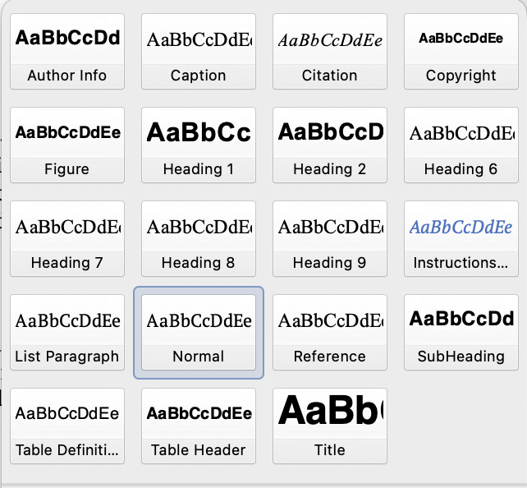

Figure 1. Selection of Heading Type and Multilevel List

## Second Level Subheading (Heading 2)

The second level subheadings should be left aligned, bold, 15 pt, Helvetica font and occupy a single line alone. An example of second level subheading in this template is Manuscript Format.

### Third Level Subheading (Heading 3)

The third level subheadings are to occupy a single line alone and should be left aligned, bold, 12 pt, Helvetica font. Capitalize main words. An example of third level subheading is the heading for this paragraph.

# Specific Section Instructions

This section describes specific instructions for page layouts, exhibits, and special sections.

## Paper Title and Author Information

The first page shall contain the title in full capital letters, left aligned, across the entire page. Use 24 pt Helvetica bold font for the title.

### Author’s identifying information

Information regarding author(s) name and contact information should only be added to the last submission. Do not add at any other time.

Five lines should be used for each author to include author’s name, and suffixes in Line 1, Author’s affiliation/organization in Line 2, Author’s contact information in Line 3 and 4, and Author’s email address in Line 5. Use 12 pt bold Helvetica font for all author line(s). Each author will place their name and subsequent information within the corresponding table cell as shown at the beginning of the document.

## Manuscript Structure

The manuscript should include at least the following sections: abstract, introduction, text body, conclusions, and references. Acknowledgement of funding support and/or any other kind of assistance should be contained in an Acknowledgements section located immediately before the References.

### Abstract

All manuscripts are to include an abstract of no more than 300 words. The abstract should give purpose, scope, and principal results and conclusions. It should not contain literature citations or formulas. This abstract should be the same as entered in EasyChair.

### Introduction

The introduction should state the problem or issue addressed in the paper, the background surrounding the elements of the paper, and the reason for the study or inquiry.

### Tables, Figures, and Captions

Number figures consecutively, and place within the body of the text, using the *Figure Style*. A period should follow the figure number. The caption of each figure should follow the heading and figure number and be followed by a period.

Try to avoid boxing figures but, if necessary, use the format as shown in Figure 3. Center the figure number and caption. Cite each figure in the text before it appears. Use portrait layout always unless it is absolutely necessary to use landscape layout. As an example, Figures 2 and 3 show how to format a figure with or without a box.



Figure 2. Example Figure Without Border



Figure 3. Example Figure With Border

A 10 pt space should separate the figure or table from the caption and a 10 pt space should separate the caption from the subsequent text that follows. Excessive white space should be avoided. Some white space at the bottom of a column is acceptable if it precedes an figure or new section heading. Table 1 is an example of where such white space appears to be logical, as the caption must be below the table (or figure).

If possible, tables and figures should be placed at the top of the page. However, inline formatting is acceptable, but not preferred. If possible, tables and figures should be placed within a single column. However, tables and figures that span both columns (within template margins) are acceptable, but not preferred.

### Mathematical notations and equations

Each displayed equation should be preceded and followed by a single blank line. Display only the most important equations, and number the equations referenced in the text. Within the display, enclose the equation number in parentheses and place it flush with the right-hand margin of the column. Equation (1) is shown below.

(1)

### References

References should be complete, clear, styled as shown below, and listed alphabetically by author (chronologically for a particular author). Place the list of references after recommendations. The section should begin with the major heading References. Only references cited in the text should be included.

|  |  |
| --- | --- |
| Sections | Definitions |
| Abstract | Purpose, scope, and main results and conclusions |
| Introduction | Problem or issue, background, and reason for the study |
| Text Body | Methodology, analysis, or other value added process |
| Conclusions | Summary in layman's terms of the result of this study |
| Recommendations | Specific steps to follow  as a result of this study |
| Acknowledgements | Note funding support and/or  other assistance |
| References | Published sources of information used in support of this study |

Table 1. Typical Sections of Your Paper

Use American Psychological Association (APA) style of referencing for both in-text citation and reference list. For more information on APA style, please see the Basics of APA style tutorials on APA website: <https://apastyle.apa.org/style-grammar-guidelines/references/examples/conference-proceeding-references>.

Another good source of information can be found at Purdue Online Writing Lab: https://owl.purdue.edu/owl/research_and_citation/apa_style/index.html.

Following APA style, in-text citation should be (Author, year) for any form of references including journal articles, conference proceedings, books, and other forms of publications. Examples of in-text citation: (Denton, 1996) for one author, (Amos and Sarchet, 1980) for two authors, and (Keating et al., 2000) for three or more authors. Note that for works with three or more authors, use "et al." from the first citation onward.

For the list of references at the end of the manuscript, following the APA style, the reference should contain Author(s)' Last Name and Initials, (Year). Title of manuscript in sentence case (capitalize the first word, the first word after a colon or dash, and proper nouns). Publication Title (e.g., Journal Title, Conference Name) in Italics, Volume (Issue), pages.

Please see the References section of this template for more information. Use hanging indentation to distinguish individual entries; the indentation should be one-half inch from left margin. Do not insert blank lines between references.

In the Reference list of this template, the first reference is a website, second reference is a book, third reference is a refereed journal article, fourth reference is a printed proceeding from a conference, fifth reference is a conference proceeding on CD-ROM, and last reference is a website.

If you are using word processing software that has a citation and referencing capability, we recommend using it, however care should be taken in checking the correctness and accuracy of such citations and references.

### Highlighting text or citations

Text of this category must be italicized, justified, and have 1.5-inch margins all around. This ensures that important material is highlighted facilitating meaning conveyance.

### Recommendations

We strongly encourage you to use this document as a template for developing your own manuscript.

# References

American Psychological Association. (2020). *Conference proceeding references*. Retrieved September 5, 2025, from https://apastyle.apa.org/style-grammar-guidelines/references/examples/conference-proceeding-references

Amos, J. M., & Sarchet, B. R. (1980). *Management for engineering*. Prentice Hall.

Denton, K. D. (1996). Imprinting change on your organization. *Industrial Management, 38*(6), 4–7.

Keating, C. B., Jacobs, D. A., Dryer, D., Unal, R., & Sousa-Poza, A. (2000). Design of collaborative engineering work systems. In *Proceedings of the 2000 ASEM National Conference* (pp. 435–442).

Price-Wilkin, J. (2002). Using the World Wide Web to deliver complex electronic documents: Implications for libraries [CD-ROM]. In *Proceedings of the 2002 ASEE Annual Conference*.

Purdue Online Writing Lab. (2025). *APA style (7th edition)*. Retrieved September 5, 2025, from https://owl.purdue.edu/owl/research_and_citation/apa_style/index

# Biography

|  |  |
| --- | --- |
|  | Author Name Provide a short biography of the author. Provide a short biography of the author. Provide a short biography of the author. |
|  | Author Name Provide a short biography of the author. Provide a short biography of the author. |
|  | Author Name Provide a short biography of the author. |