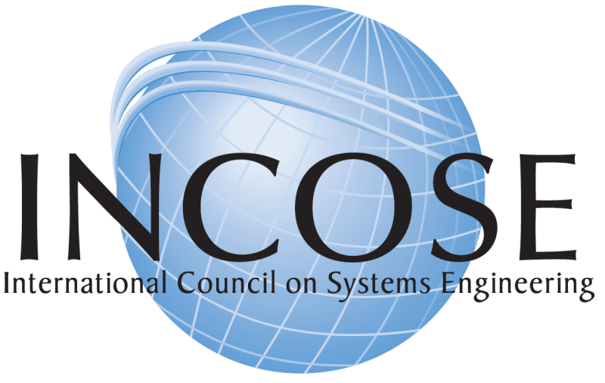

**FOR OUR GUESTS**

**PLEASE TAKE ONE**

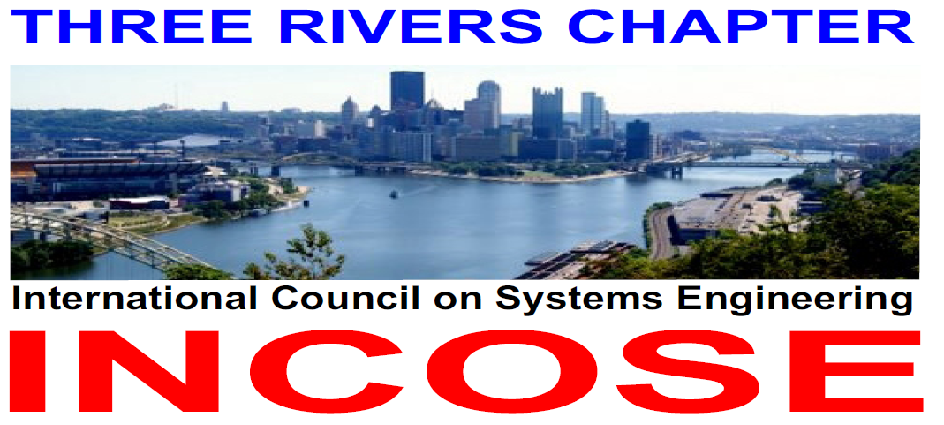

Welcome to this meeting of the Three Rivers (Pittsburgh) Chapter of the International Council on Systems Engineering (INCOSE). These meetings are held monthly, usually on the fourth Thursday of the month. Attendance is open to all; you need not be a member of INCOSE or the Three Rivers Chapter to attend.

Our meetings typically include

1. A networking session where all present can meet and discuss topics of interest with their peers
2. A brief business meeting where topics pertaining to the operation of INCOSE and the Three Rivers Chapter are discussed
3. A technical session, which typically consists of a technical presentation, a panel discussion, or a workshop.

The technical presentations focus on an aspect of systems engineering, and are always informative and interesting. Some of the presentations offered in the past have included:

* **Configuration Management: An Integrated Systems Engineering Process**

Nancy Jo Roseberry, Westinghouse Electric Company

* **Bridging Concept to Design: How to create, evaluate and use System Architectures**

John Ackley, Software Engineering Institute

* **Ethnographic Research - Incorporating the Customer’s Voice into Product Requirements**

Matt Beal, President, Daedalus Excel

* **Safety Risk Management for Medical Devices Process and Pitfalls**

Ron Heller, Medrad Inc.

* **Leveraging Systems Engineering to Improve Program Performance**

Joe Elm, Software Engineering Institute

* **Best Practices of Using Rational DOORS at Westinghouse**

Paul Lusardi, Westinghouse

The chapter also sponsors research projects and initiatives within INCOSE. Presently we are supporting the “Systems Engineering Effectiveness Study”, a project that is identifying, documenting, and promoting the use of systems engineering practices that can be shown to provide benefit for development projects.

We hope you enjoy this meeting, and we welcome you back to future meetings. If you are not a member of INCOSE, we encourage you to join (go to [www.incose.org](http://www.incose.org) and click / Membership/Join INCOSE). If you are already an INCOSE member, we encourage you to join the Three Rivers Chapter.

Joseph Elm

President, INCOSE Three Rivers Chapter

**Three Rivers Chapter Contact information**

|  |  |  |  |
| --- | --- | --- | --- |
| **President** |  | **VP & President-elect** | |
| Joseph Elm  Software Engineering Institute  Carnegie Mellon University  4500 Fifth Ave.  Pittsburgh, PA 15213  telephone: 412-268-9132  email: [jelm@sei.cmu.edu](mailto:jelm@sei.cmu.edu) |  | Nancy Roseberry  Westinghouse Electric Company  Nuclear Automation  Suite 252  1000 Westinghouse Drive  Cranberry Township, PA 16066  telephone: 412-374-2611  email: [rosebenj@westinghouse.com](mailto:rosebenj@westinghouse.com) | |
| **Secretary** |  | **Treasurer** | |
| Bonnie McDonough  Parsons Corporation  603 Stanwix Street # 1776 Pittsburgh, PA 15222-1421  telephone: 724 799-2389  email: Bonnie.Mcdonough@parsons.com |  | Frank Sciulli  Westinghouse Electric Company  Nuclear Automation  Suite 252  1000 Westinghouse Drive  Cranberry Township, PA 16066  telephone: 412-374- 3201  email: [sciullfj@westinghouse.com](mailto:sciullfj@westinghouse.com) | |
| **Program Committee Chair** |  | **Membership Committee Chair** | |
| Paul Miller  5714 Elgin St  Pittsburgh, PA, 15206  telephone: 412 999-7568  email: [riverhorse@mindspring.com](mailto:riverhorse@mindspring.com) |  | Larry McCutchan  Medrad, Inc.  625 Alpha Drive Pittsburgh, PA 15238  Telephone: 412 860-7304  email: [lmccutchan@medrad.com](mailto:lmccutchan@medrad.com) | |
| **Communications Committee Chair** |  | **Web Sites** | |
| Hal Knisley  Invisioneering  542 Fairview Ave. Sidman, PA 15955-3414  telephone: 814-418-4126  email: [hal.knisley@invisioneeringllc.com](mailto:hal.knisley@invisioneeringllc.com) |  | INCOSE: | [www.incose.org](http://www.incose.org) |
| Three Rivers Chapter | [www.incose.org/threerivers/](http://www.incose.org/threerivers/) |

**“Why should I join INCOSE?”**

The International Council on Systems Engineering (INCOSE) is the premier professional organization that emphasizes a systemic approach to problem solving. In today’s global competitive environment, workers and companies need that single characteristic to distinguish them from all of the others. That characteristic is Systems Engineering.

Why Systems Engineering? Simply stated, systems engineering is the only discipline that considers all aspects of problem solving, from defining the problem set to developing a solution, all while consideration is given to the outside environmental and enterprise effects that may impact the result. Systems Engineering is used by all problem solvers; scientists, both organic and social, engineers, both product and human, and by everyday workers trying to help their companies solve tomorrow’s problems today.

How can I be a part of this global engine? In one word, **INCOSE**! For companies to be competitive, their workers must leverage their skills and characteristics to outshine others. Systems Engineering provides that leverage. Members of INCOSE have access to the leverage provided by Systems Engineering through interfaces with other system engineering professionals via presentations and networking, professional development through courses and symposia, and finally via access to a vast knowledge library readily available to INCOSE members.

By interfacing with other INCOSE members, by participating in chapter activities, supporting a technical working group, or by attending symposia, you continually increase and enhance your knowledge of and skill in this vital characteristic. Interacting with other INCOSE members provides one of the best learning vehicles you, as a professional, can access. Your participation in chapter activities provides you a wealth of networking opportunities with a variety of professionals skilled in requirements, risk, design and engineering, verification (V&V and Q&A), tools and training, simulation and modeling, etc. Many of your fellow members share their expertise and experiences by speaking at chapter meetings or just chatting during the social hour. What an invaluable way to learn!!

You can improve yourself professionally by attending the various tutorials offered by INCOSE. These high-value, low-cost courses are taught by highly skilled and experienced practitioners of Systems Engineering at your chapter meetings or at the yearly International Symposium. Most of these courses qualify for continuing education units at universities and they provide the professional development units needed for maintaining your Certified Systems Engineering Professional status. Yes, you can earn a certification as a Systems Engineering Professional, which will place you among select company. Your membership and involvement in INCOSE will facilitate your gaining this certification as you interact with other system engineering professionals, attend tutorials, and improve your skills and knowledge regularly.

You, as a valued INCOSE member, will have access to the greatest library of systems engineering knowledge available anywhere. From the presentations and networking at chapter activities, attendance at tutorials and symposia, supporting the technical working groups creating and developing new and evolving standards, to the INCOSE Process Asset Library (IPAL). The IPAL, besides providing access to the combined knowledge on INCOSE, will also provide access to the combined knowledge of Government, Industry, and Academia as these INCOSE member institutions share their vast knowledge base. This knowledge encompasses the areas of Education & Research, Modeling & Tools, Process & Improvement, SE Applications, SE Initiatives, SE Management, and Standards.

Whether you are just out of college or have been a professional for many years, INCOSE has something for you. As a young professional, you are building a résumé to prepare yourself for future job and personal growth challenges. You enhance your abilities by participation in educational and networking activities via your involvement with other INCOSE members. You learn, develop, and practice leadership skills via your participation in chapter activities, first as a volunteer and then as a chapter officer.

You, as a seasoned professional, have risen through the hierarchy of needs and are looking for fulfillment in additional ways. You can apply your knowledge and leadership to the technical groups and committees, serving in INCOSE leadership positions, or mentoring the young professionals embarking on their careers.

Wherever you are in your career, your ability to see problems from a systems view, gives you the edge for the new jobs and challenges you seek. This is why YOU should join INCOSE. You and INCOSE can make a difference.