INCOSE

Southern Maryland (SoMD) Chapter

Membership Plan

1 April 2010

CHANGE RECORD

Change Number | Date | Title or Brief Description | Person Making Change
1 | 2/22/10 | Added title page, Change Record, and Table of Contents. Changed enclosures to appendices. Added headings and moved contents under correct heading. Section 4 was modified. Added sample Letter of Appreciation. | Dawn Jaeger

TABLE OF CONTENTS

1. Introduction 1
2. Recruitment 1
3. Retention 1
4. Renewal 2
Appendix A: Prospective Member Letter 3
Appendix B: INCOSE Survey 2009 6
Appendix C: Sample Letter of Appreciation 10
Appendix D: Membership Renewal Letter 11
Appendix E: INCOSE Past Member Survey 13

1. Introduction
The intention of this plan is to present the INCOSE Southern Maryland Chapter’s strategy for recruiting and retaining chapter membership.

Four primary strategies will be utilized or engaged to both maintain and increase the membership of the chapter:

1. Involvement
2. Communications
a. Solicitations/recruitment
b. Reminders
c. Personal Invitations
3. Reimbursement
4. Recognition

Involvement is an attempt to approach every chapter member and every prospective member to participate in the Chapter's meetings, Board of Directors (BOD) meetings, Working Groups, and Chapter activities and events (such as conferences, tutorials, and service projects). The theory being involvement generates interest, and interest generates satisfaction. Satisfied members are more likely to participate and then renew their membership.

Communications includes both solicitations and reminders. This includes the act of sending e-mails and flyers to every Chapter member and all prospective members concerning Chapter activities and events.

2. Recruitment
The Chapter will recruit during two social events per year, which are a means to:

  - Attract and recruit prospective members in relaxed, social environment
  - Thank the Chapter membership for their participation throughout the year
  - Formally present letters of appreciation to Chapter members
  - Briefly highlight key Chapter activities and strategic direction

Also, we distribute new member packets to non-members at each activity or event which includes a letter explaining the benefits of INCOSE (see Appendix A). Personal communications will also continue for people who have expressed interest in INCOSE but have not yet joined.

3. Retention
Periodically, a link to an online survey (see Appendix B) will be sent to the Chapter membership to aid in setting the direction of the Chapter and addressing member desires. Results will be tabulated and discussed at the annual BOD Strategy Meeting or at a Board of Directors (BOD) Meeting.

Reimbursement refers to the act of paying for part or all of the expense for participating chapter members for their participation in an activity or event. This displays the theory here is giving something back to every member for his or her involvement. It can range from discounted prices for Chapter luncheons to financial support for travel to official INCOSE events where the individual represents the Chapter’s interests.

The Chapter President will formally recognize those members who contribute to the overall success of the Chapter. As was stated before, formal awards will be presented at the Holiday Party at the end of the year. Letters of appreciation will also be awarded after Chapter events (such as the Science Fair, Student Unmanned Air Systems competition, etc.) recognizing members for their contributions (sample in Appendix C). The supervisors of these award recipients will be notified of the accomplishments. The Chapter will also nominate worthy members for INCOSE Founder, Fellow, and Service Awards.

4. Renewal
The Membership Chair will create a Chapter Roster with membership expiration dates. Members will be identified monthly whose membership are about to expire. Friendly reminders will be sent to those Chapter members whose membership is about to expire (see Appendix D), or have expired, and to encourage them to renew. For those not renewing, a request will be sent to them via e-mail to fill out the INCOSE Past Member Survey, which will be available online (see Appendix E). Results will be tabulated and reported to the Chapter Board of Directors. The results for the year will be also be reported to INCOSE Headquarters at the end of the calendar year.

Appendix A: Prospective Member Letter

To Prospective INCOSE Members,

In the November 2009 Edition of Money Magazine, systems engineering was rated as the fastest growing and most needed profession globally. For that single reason, membership in the International Council on Systems Engineering (INCOSE) has never been better or more valuable. Please let us take a minute to explain the advantages of an INCOSE Membership.
A membership in the International Council on Systems Engineering will continue to expand your view of the engineering of complex systems and your knowledge of the many aspects of the SE practice. Project managers, software engineers, hardware engineers, system integrators, and product developers have joined INCOSE to learn how to use the systems engineering processes and apply them to their programs. This can increase global perspective of your programs and responsibilities, and teach you how the application of systems engineering techniques can improve job performance and organizational well being.
With INCOSE membership, you'll receive the following:
- Networking opportunities with more than 7500 SE professionals in 54 Chapters in more than 30 countries
- Availability of Quarterly Publication, INSIGHT (hardcopies $20)
- Availability of Systems Engineering, the Journal of INCOSE (hardcopies $30)
- Opportunities to contribute through INCOSE Working Groups
- Opportunities to collaborate with Experts and Practitioners
- Discount Prices on INCOSE Products and Publications
- Exclusive access to the Members' Only Area on INCOSE’s website http://www.incose.org
- Special Downloads
- Membership Directory
- Current issue of INSIGHT
- Systems Engineering Handbook (Various revisions, no charge to members in softcopy)
- Measurement Primer (No charge to members in softcopy)
- Current and past issues of the Journal
Your membership supports:
- Annual International Symposia
- Annual International Workshops
- Local Chapter Operations www.incose.org/so-md/
- INCOSE World Wide Web http://www.incose.org
- INCOSE Listserver (for online discussions)
- INCOSE Representation on Standards Committees
- Professionally Operated INCOSE Office
You'll have opportunities to purchase
- INCOSE Guidebooks and Handbooks
- Annual Proceedings on CD-ROM
- Products from Technical Committee
Additionally, the Local Chapter (Southern Maryland) activities include:
- Monthly Chapter Luncheon or Dinner Meetings with interesting topics and speakers at reduced cost
- Participation in co-sponsored events with other organizations like Software Process Improvement Network (SPIN), Association for Unmanned Vehicle Systems (AUVSI), or System Safety Society (SSS)
- Participation in Regional INCOSE Conferences like the INCOSE Spring 09 Conference (2-4 April 2009)
- SE Working Groups
- And much more!
If you are interested in joining our local chapter of INCOSE (Southern Maryland Chapter), or any INCOSE chapter, the easiest way is to go to the INCOSE website at https://www.incose.org/cc_orders/joinINCOSE.cfm and apply electronically. Currently, yearly dues are $105. We are looking forward to having you in the Chapter and experiencing the “INCOSE Difference” in Systems Engineering.

Respectfully,
Dawn Jaeger, Steve McKeown, and Karl Geist
SoMD Chapter Membership Committee

Appendix B: INCOSE Survey 2009

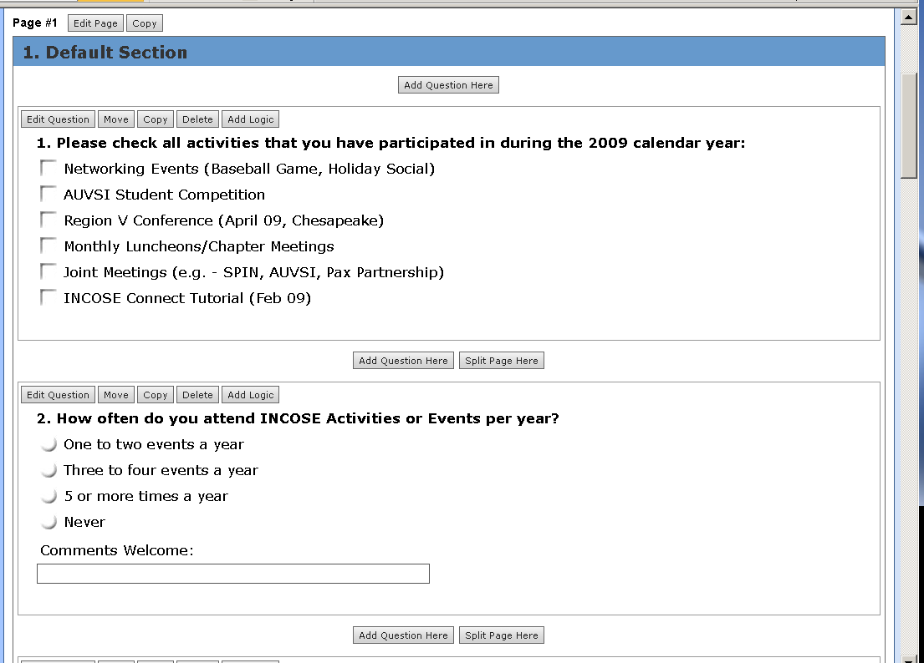
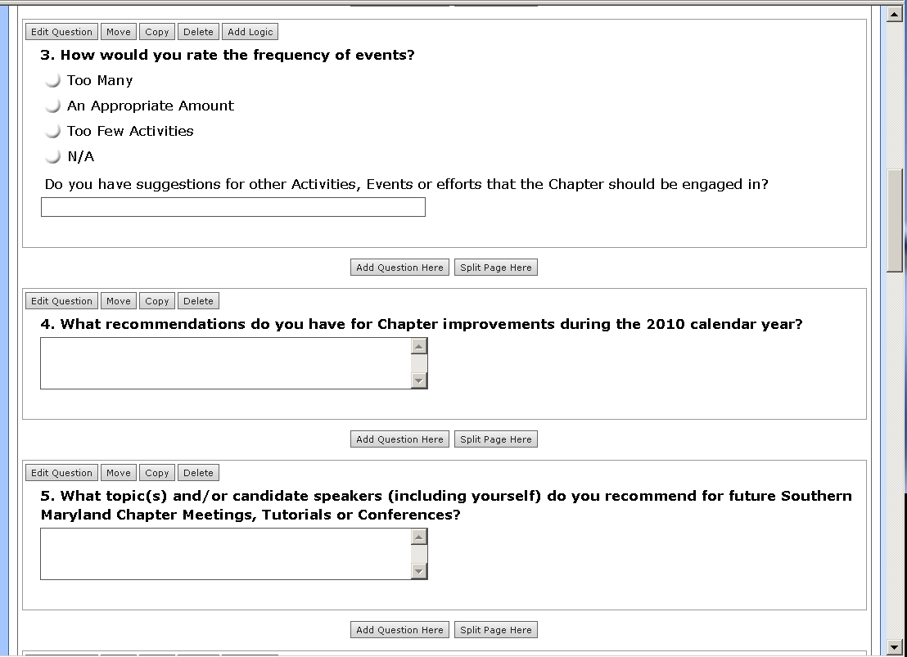
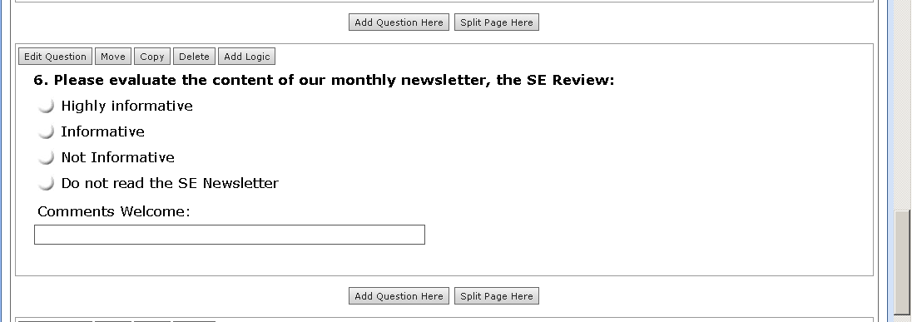
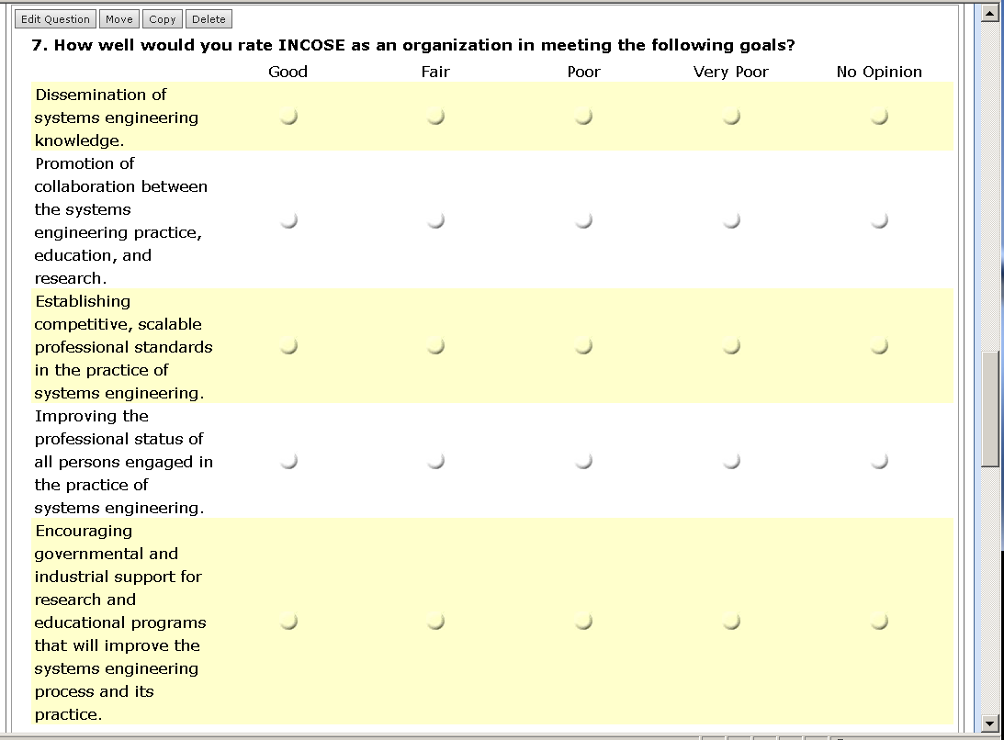

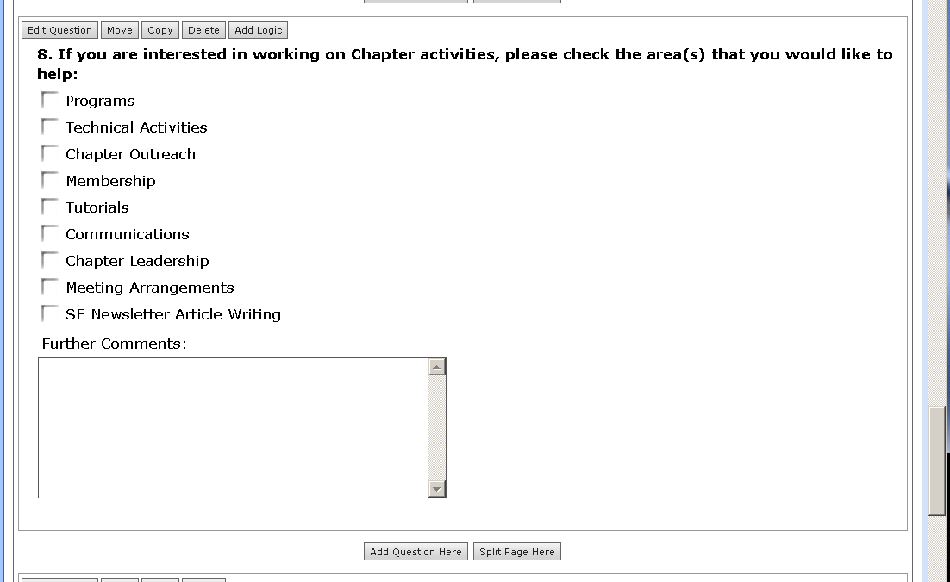
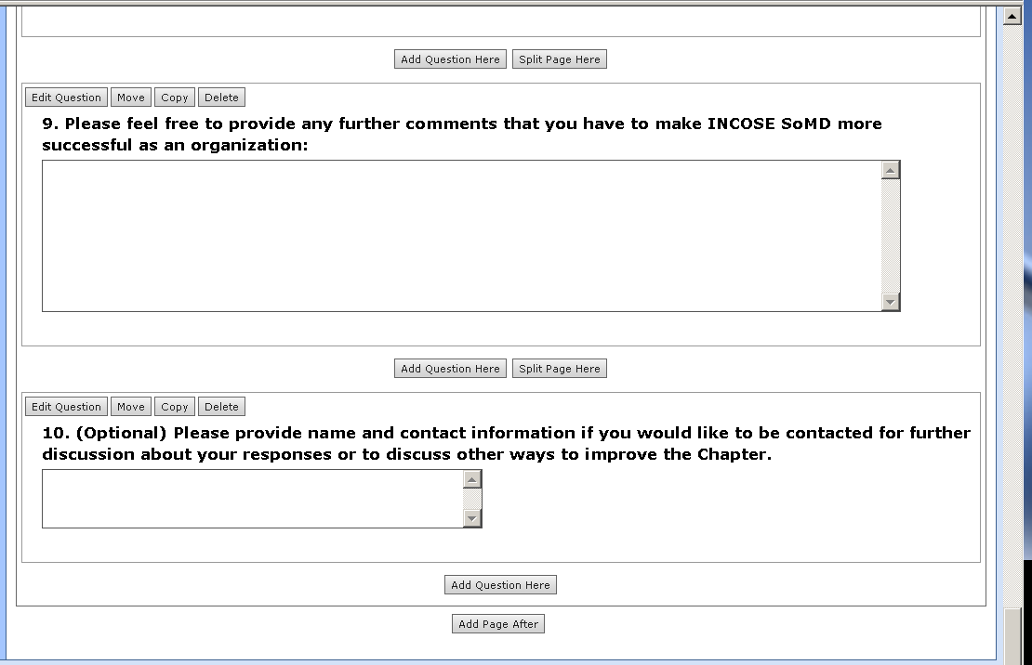

Appendix C: Sample Letter of Appreciation

15 December 2009

From: Steve McKeown, INCOSE Southern
MD President 2009
Subj: Letter of Appreciation

Dear Karl Geist,

It is a privilege to express my appreciation for your contributions to the success of the INCOSE Southern MD Chapter.

During 2009, you were integral to INCOSE success on both local and regional levels. I would like to focus on two specific accomplishments that are indicative of your long-term commitment to INCOSE.

The first would be the vital role that you played for the Region V Spring 09 Conference entitled “Systems Engineering – Affordable Success”. As Chairman for the conference, you were a driving force in gaining Region V Chapter commitment for this event. It took real dedication to synchronize logistical requirements and technical program content for a successful event, in this case benefitting 100+ INCOSE members and sponsors in Hampton Roads, VA over a 4-day period.

The second event was your support with the AUVSI UAS Student Competition. In this capacity, you have lead our Chapter in establishing a long-term relationship with AUVSI and served to coordinate INCOSE support efforts for the student reception and additional needs for the remainder of the event. This was an enabler for the competition and promoted INCOSE as a professional association to our community and to the numerous colleges that participated in the event.

Congratulations on a job well done!

Steve McKeown

Appendix D: Membership Renewal Letter

Dear INCOSE Member,
We have been informed that your INCOSE Membership has or is about to expire. Please let me take a minute to remind you of the advantages of an INCOSE Membership.
A membership in the International Council on Systems Engineering will continue to expand your view of the engineering of complex systems and your knowledge of the many aspects of the SE practice. Project managers, software engineers, hardware engineers, system integrators, and product developers have joined INCOSE to learn how to use the systems engineering processes and apply them to their programs. This can increase global perspective of your programs and responsibilities, and teach you how the application of systems engineering techniques can improve job performance and organizational well being.
With INCOSE membership, you'll receive the following:
- Networking opportunities with more than 7500 SE professionals in 54 Chapters in more than 30 countries
- Availability of Quarterly Publication, INSIGHT (hardcopies $20)
- Availability of Systems Engineering, the Journal of INCOSE (hardcopies $30)
- Opportunities to contribute through INCOSE Working Groups
- Opportunities to collaborate with Experts and Practitioners
- Discount Prices on INCOSE Products and Publications
- Exclusive access to the Members' Only Area on INCOSE’s website http://www.incose.org
- Special Downloads
- Membership Directory
- Current issue of INSIGHT
- Systems Engineering Handbook (Various revisions, no charge to members in softcopy)
- Measurement Primer (No charge to members in softcopy)
- Current and past issues of the Journal
Your membership supports:
- Annual International Symposia
- Annual International Workshops
- Local Chapter Operations www.incose.org/so-md/
- INCOSE World Wide Web http://www.incose.org
- INCOSE Listserver (for online discussions)
- INCOSE Representation on Standards Committees
- Professionally Operated INCOSE Office
You'll have opportunities to purchase
- INCOSE Guidebooks and Handbooks
- Annual Proceedings on CD-ROM
- Products from Technical Committee
Additionally, the Local Chapter (Southern Maryland) activities include:
- Monthly Chapter Luncheon or Dinner Meetings with interesting topics and speakers at reduced cost
- Participation in co-sponsored events with other organizations like Software Process Improvement Network (SPIN), Association for Unmanned Vehicle Systems (AUVSI), or System Safety Society (SSS)
- Participation in Regional INCOSE Conferences like the INCOSE Spring 09 Conference (2-4 April 2009)
- SE Working Groups
- And much more!
The easiest way to renew is to go to the INCOSE website at http://www.incose.org/membership/renew.aspx and renew electronically. Currently, yearly dues are $105. We hope you are taking advantage of your Chapter Membership and are looking forward to having you continue in the Chapter.
Respectfully,
Dawn Jaeger, Steve McKeown, and Karl Geist
SoMD Chapter Membership Committee

Appendix E: INCOSE Past Member Survey
