

**D R A F T**

INCOSE-WMA Chapter

2011 Operating Plan

***ADDENDUM A – Communications PLAN***

**06 April 2011**

**Revision 1.0**

**Approved By**

**Officers**

**______/signed/__________ ________/signed/_______**

**President Vice-President/President-Elect**

**Mr. Kevin Weinstein Ms. Laurie Nasta**

_____________________________

**Past President**

**Dr. Steven Dam**

**_____/signed________ ________/signed________**

**Treasurer Secretary**

**Ms. Eileen Moore Dr. Paul Montgomery**

**Directors-at-Large**

**______________________ __________________________**

**Mr. Edward Ghafari Mr. Matthew Dismer**

**WMA Chapter Committee Chairpersons**

**___/R Posadas signed for/___ __________/signed/________**

**Programs Committee Chair Communication Committee Chair**

**Ms. Jana Richards-Taylor Mr. Chris Ritter**

**________concur___________**

**Membership Committee Chair**

**Ms. Kristine Hejna**

Table of Contents

1 Purpose of Plan 4

1.1 Applicable Documents 4

2 Website 4

2.1 Overview 4

2.2 2011 Website Architecture Plan 5

2.2.1 Phase One 5

2.2.2 Phase Two 6

2.2.3 Schedule 6

3 Publicity Plan 6

3.1 Newsletter 6

3.2 Website 6

3.3 Mailing Lists 7

3.3.1 Upcoming Event Email 7

3.3.2 Last Change to Register Email 7

3.4 New Member Publicity 7

3.5 Identity 7

3.6 2011 Communications Schedule 7

4 Personnel 8

**Changes Log**

| **Revision** | **Changes** | **Approval Date** |
| --- | --- | --- |
| 1.0 | Initial Issuance | 7 Apr 11 |
|  |  |  |

# Purpose of Plan

The purpose of this Communications Plan is to provide an overview of the intent and goals for the INCOSE-Washington Metro Area (WMA) Chapter Communications Program and to provide guidance for the ongoing operation of the Communications Program. As defined by the INCOSE organization, Communications is responsible for the following:

* Managing and maintaining all communications tools, to include but not be limited to, Chapter Website, INCOSE Connect website, presence on other Social Media sites, and updating/maintain the Chapter e-mail reflectors (for BOD and for membership at large)
* Coordinating the production of the monthly newsletter, and publish to Chapter Website and announce availability to membership
* Publishing/broadcasting Meeting, Tutorial and other Event reminders, to include important INCOSE.org notices
* Developing Communications Plan (Addendum A to Operating Plan) to include Website Plan, Publicity Plan
* Coordinating implementation of the Chapter Ambassador Plan (Ambassador Program Lead designated by Chapter President)
* Contributing content to newsletters

## Applicable Documents

The chapter operating plan and its addenda, the chapter strategic plan, and the INCOSE policies and bylaws are all superior documents to the membership plan and this plan is subject to them and needs to comply with them. In the case of any discrepancy, the chapter Operating Plan takes precedence.

# Website

## Overview

The website INCOSE WMA currently uses was designed quickly in 2010 to meet the growing needs of the INCOSE WMA Chapter. The website was designed/developed in WordPress and thus includes a content management system that any board member can access.

The 2010 redesign was a quick face lift to incosewma.org created to entice members with a professional, user-friendly website. However, through this first website revision, we have learned more innovative ways to enhance usability for members and board members. The current website will be used to publish events broadcast news, display current/past presentations, and list board member contact information until a new website is designed.

## 2011 Website Architecture Plan

The 2011 website architecture will be a much larger software package developed to support the growing needs of the INCOSE WMA chapter.

### Phase One

**Website Resign**

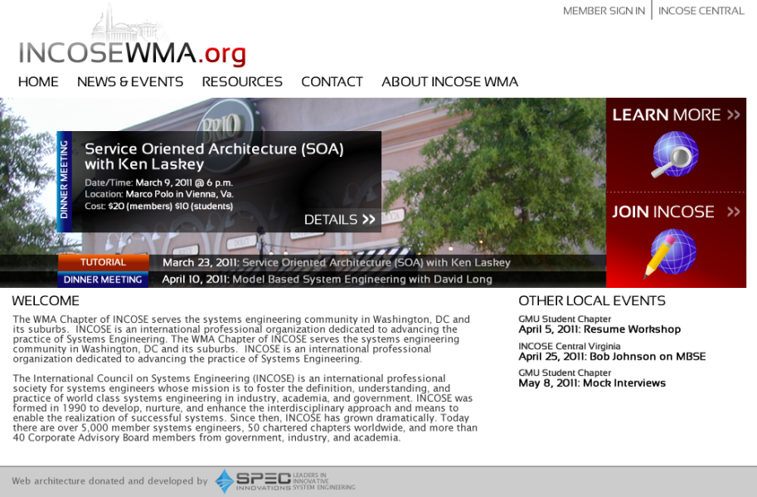The new website will move away from the 2010 redesign’s blog format style and include more information in less space. The redesign is intended to reduce the need for members to scroll down the page to attain necessary information.

The centerpiece of the redesign is a new dynamic JavaScript object that automatically scrolls through the next 4 upcoming events. All upcoming events will be color coded. Orange will designate a tutorial, blue will designate a dinner meeting, and green will designate a special event. The hope is that the centerpiece will be visually appealing and provide more information with less user intervention.

Figure 1 – Future INCOSE WMA website

The redesign will include various features to enhance chapter communication:

* a new “Welcome” section that explains what INCOSE WMA is and what are intended mission is to our community;
* a new “Other Local Events” section to display sister chapter, student chapter, and other local events prominently;
* a large “Join INCOSE” button that allows members to quickly join INCOSE or renew their membership with INCOSE;
* and a learn more button.

**Content Management System**

The website will include a new content management system based upon an open source content management system.

**Events System**

The website will include an events system that will allow for the Programs Committee to easily update content on the website. The events system will be highly integrated with INCOSE Connect to:

* give members a verified discount;
* allow INCOSE WMA to save address/phone number information;
* and provide less duplication by using already existing INCOSE Connect login information.

### Phase Two

**Forum System**

A new forum system will be integrated with the website to allow members to communicate with each other, the board of directors and students. The forum system will be integrated with members INCOSE Connect accounts.

### Schedule

|  |  |  |  |
| --- | --- | --- | --- |
| Task | Start Date | End Date | Assignee |
| Update current website with events | Jan. 1, 2011 | July 31, 2011 | Communications Committee |
| Implement website redesign phase one | Apr. 9, 2011 | Aug. 1, 2011 | Communications Committee |
| Train board on how to use new website | Jul. 23, 2011 | Jul. 30, 2011 | Communications Committee |
| Update new website with events | Aug. 1, 2011 | Jan. 1, 2012 | Programs Committee |
| Implement website redesign phase two | Aug. 15, 2011 | Oct. 1, 2011 | Communications Committee |

# Publicity Plan

The INCOSE WMA Communications Committee realizes that publicizing events to the chapter is necessary in order to encourage member participation at dinner meetings, tutorials, webinars, conferences, and special activities. Chapter publicity concerns the INCOSE WMA website, email system, and newsletter.

## Newsletter

INCOSE WMA will publish a newsletter monthly to communicate events, chapter news, member articles, and the president’s word. The newsletter will be sent via email on the last Tuesday of every month. All articles are due on the third Tuesday of every month.

## Website

All upcoming events will be published three months in advance by the communications committee until Aug. 1, 2011. After Aug. 1, 2011 the programs committee will publish all upcoming events at least three months in advance.

## Mailing Lists

INCOSE Central maintains three mailing lists for INCOSE WMA the:

* Active Member List wmamembers@incose.org (~830 registered)
* Guest List wmaguests@incose.org (13 registered)
* Board List wmabod@incose.org

The mailing lists are used exclusively by the INCOSE WMA Communications Committee.

### Upcoming Event Email

An upcoming event email will be sent on the third Tuesday of every month to the active member list. The upcoming event email will include a list of the next three dinner meetings and three tutorials.

### Last Change to Register Email

A last chance to register email will be sent one day prior the program committee’s registration deadline for a dinner meeting to the active member list. Currently “Last Chance” emails are sent one or two days prior to a dinner meeting.

## New Member Publicity

A membership packet (generated by the Membership committee) will be made available at every dinner meeting and tutorial. This packet will also be made available for download on our website.

## Identity

A sign with the INCOSE WMA logo will be present at all INCOSE WMA events. The sign will be brought by the event’s coordinator. The INCOSE WMA logo will be displayed prominently on the official website, official documents and at any sponsored events.

## 2011 Communications Schedule

|  |  |  |
| --- | --- | --- |
| Content Due | Sent | Task |
| April 12, 2011 | April 19, 2011 | Upcoming Events Email |
| April 19, 2011 | April 26, 2011 | April Newsletter |
| May 10, 2011 | May 17, 2011 | Upcoming Events Email |
| May 17, 2011 | May 24, 2011 | May Newsletter |
| June 14, 2011 | June 21, 2011 | Upcoming Events Email |
| June 21, 2011 | June 28, 2011 | June Newsletter |
| July 12, 2011 | July 19, 2011 | Upcoming Events Email |
| July 19, 2011 | July 26, 2011 | July Newsletter |
| August 16, 2011 | August 23, 2011 | Upcoming Events Email |
| August 23, 2011 | August 30, 2011 | August Newsletter |
| September 13, 2011 | September 20, 2011 | Upcoming Events Email |
| September 20, 2011 | September 27, 2011 | September Newsletter |
| October 11, 2011 | October 18, 2011 | Upcoming Events Email |
| October 18, 2011 | October 25, 2011 | October Newsletter |
| November 8, 2011 | November 15, 2011 | Upcoming Events Email |
| November 15, 2011 | November 22, 2011 | November Newsletter |
| December 13, 2011 | December 20, 2011 | Upcoming Events Email |
| December 20, 2011 | December 27, 2011 | December Newsletter |

# Personnel

The INCOSE WMA Communications Committee will attempt to recruit additional individuals to fill the role of:

* Newsletter Editor (who will collect articles, edit articles, and layout an INCOSE WMA newsletter every month)
* Admin (who will assist with the newsletter, updates, and the website)
* A/V Technician (who will record, capture, and post/stream video of meetings)

The INCOSE WMA Communications Committee currently only has the role of webmaster filled (by its current chair).