28 November 2025
CSRM Download - Easy Peasy
_____________________________________________________________________________________________________________________
Step 1.
Create folder: CSRM Zip Files (not shown)
Open: Space Systems Working Group Web Site: Space Systems
Open: CSRM_2025_11_18 and Download into CSRM Zip Files folder.
Where does CSRM_2025_11_18 reside?

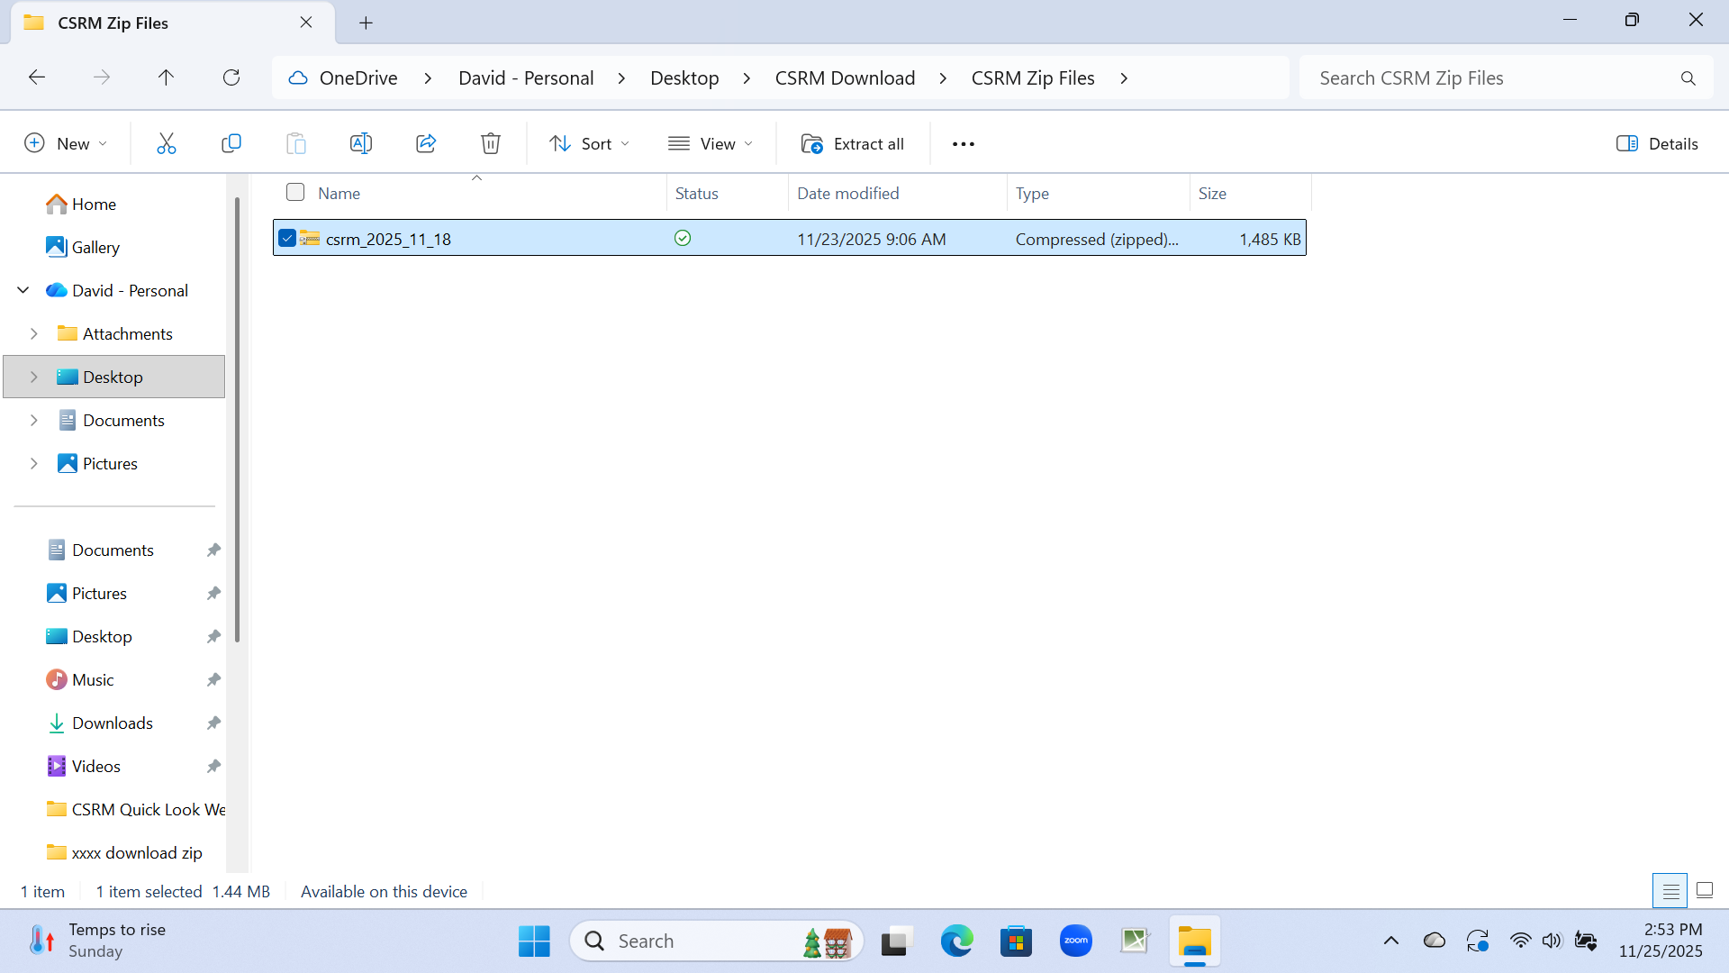
Step 2.
Extract All: csrm_2025_11_18 in CSRM Zip Files folder
xx
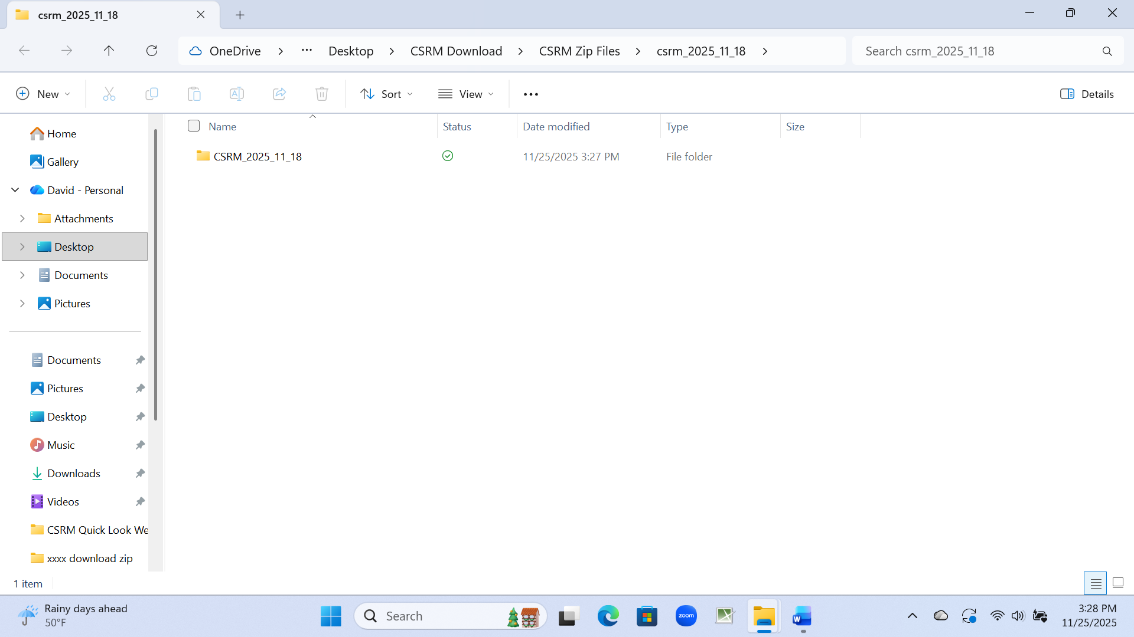
Step 3. Open
xx
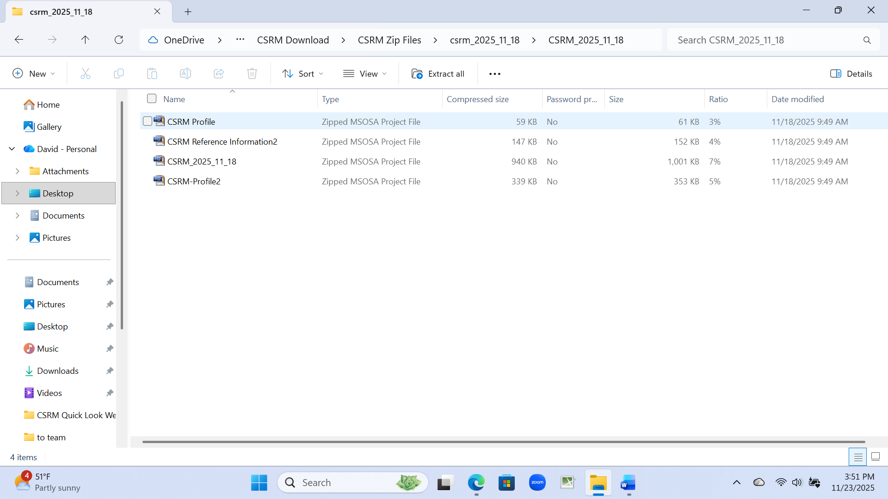
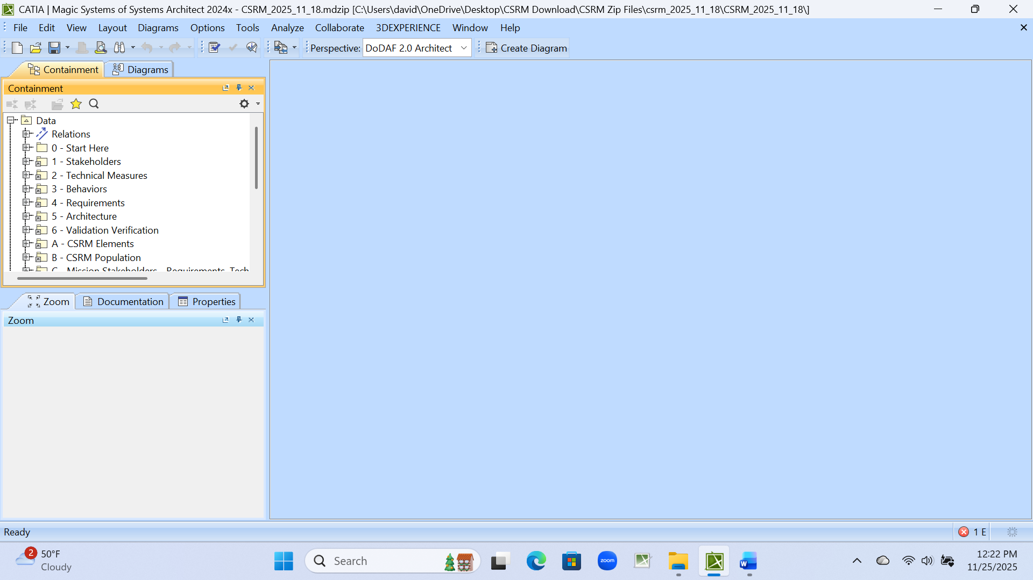
xx
xx
Step 4. Open CSRM_2025_11_18 Zipped MSOSA Project File
Step 5. Open: Start Here
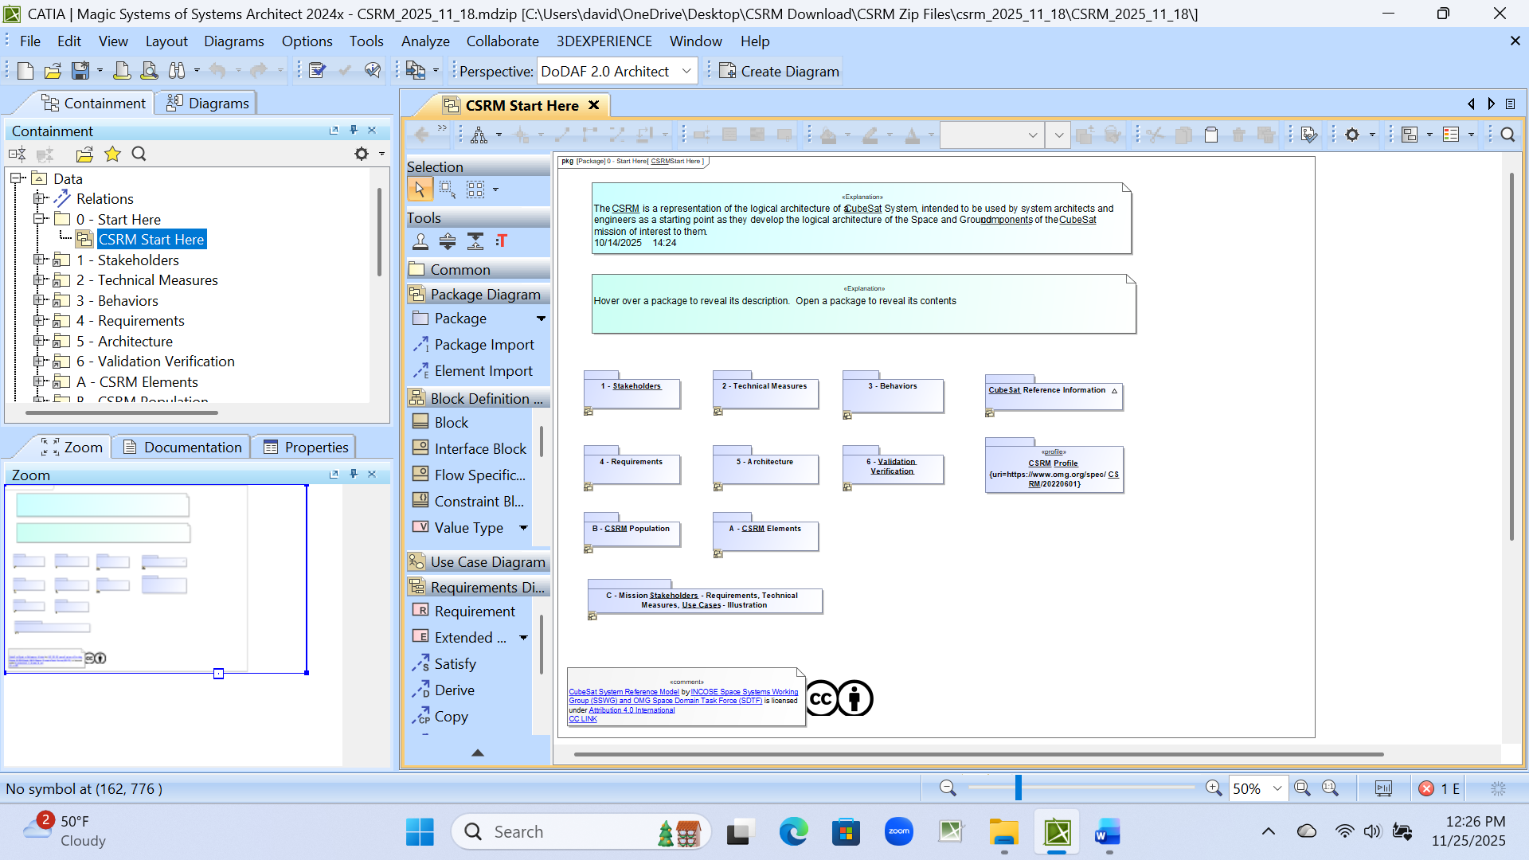
xx
Step 6. Voila
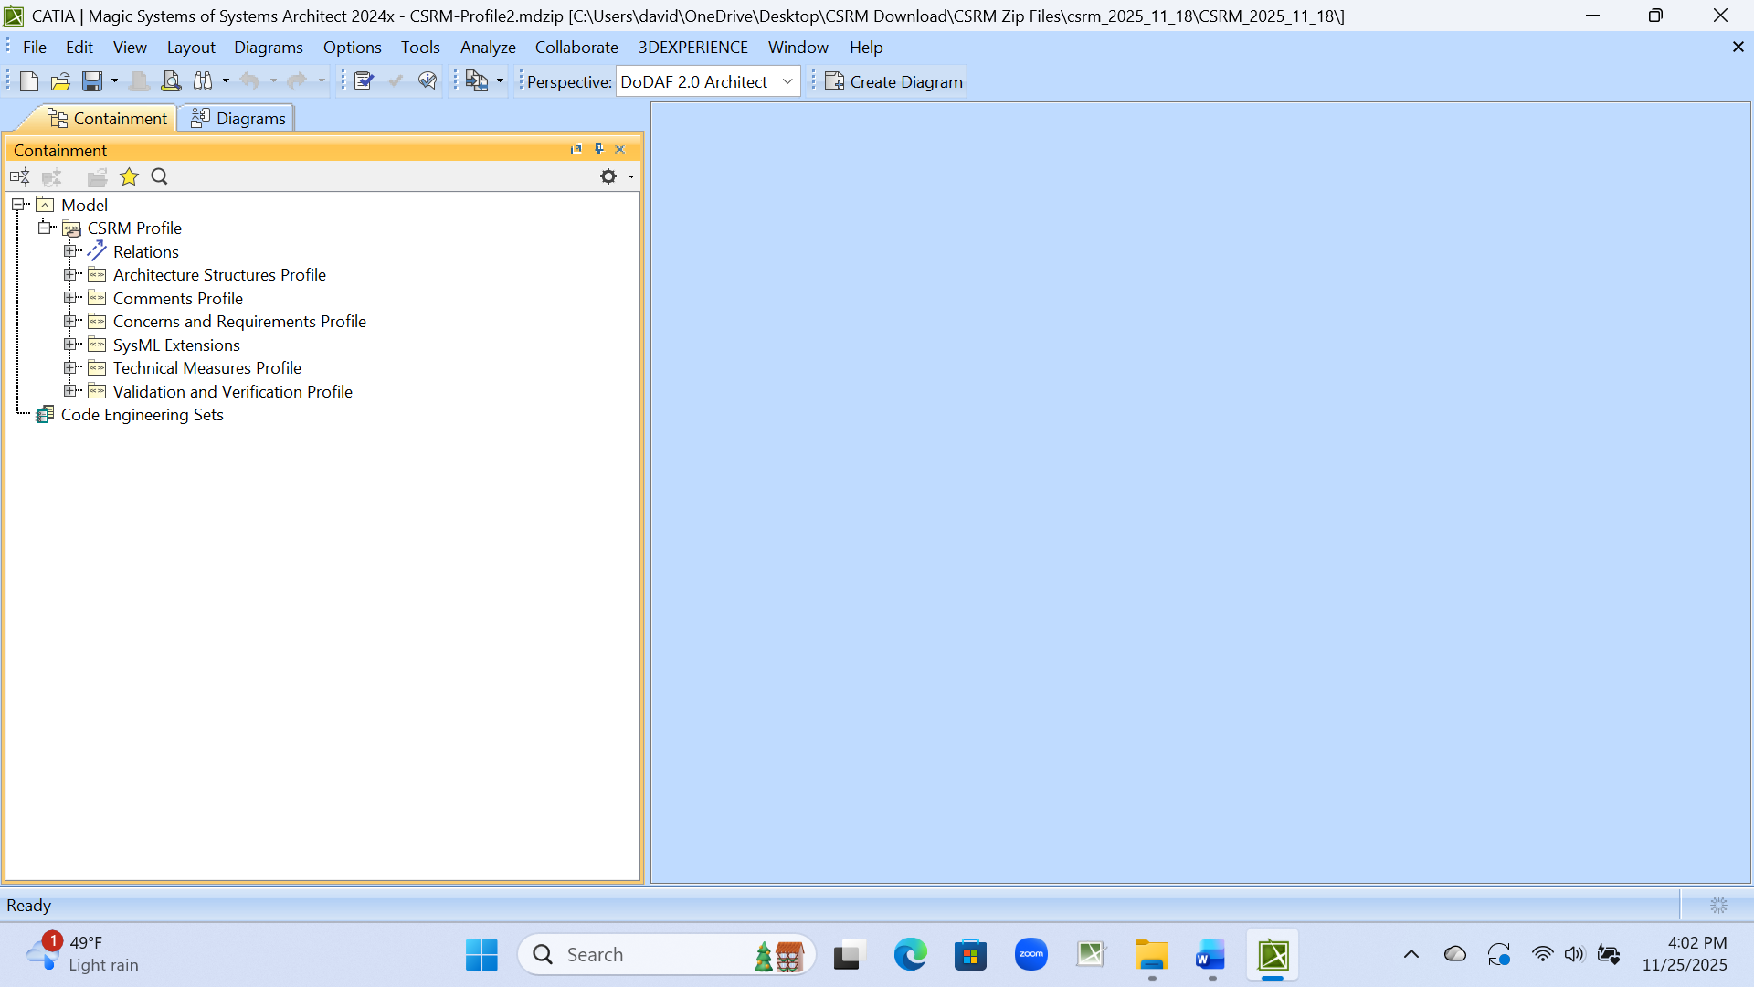
xx
Step 7. CSRM Profile
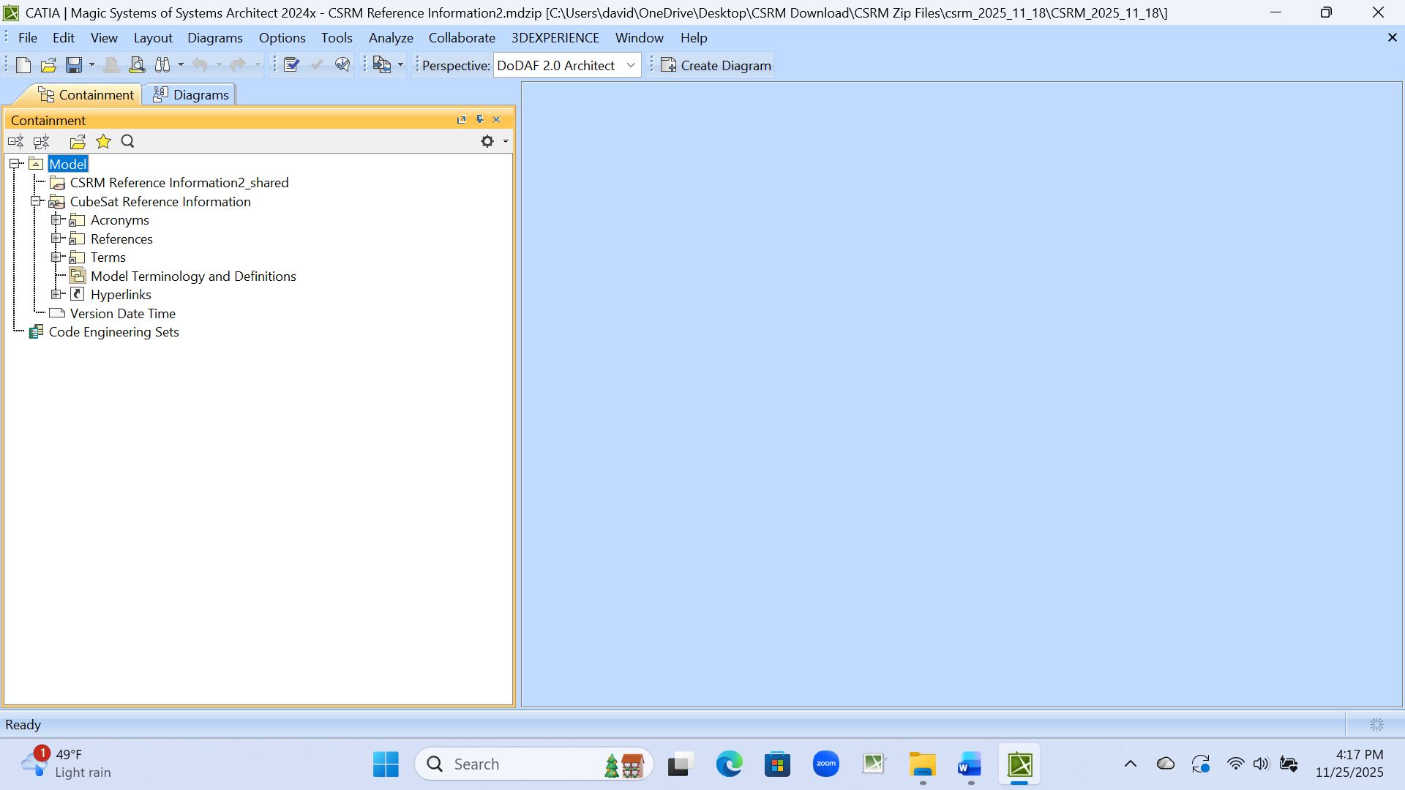
Step 8. CSRM Reference Information (or CubeSat Reference Information)

