28 November 2025
CSRM HTML Navigation
______________________________________________________________________________________
This provides the capability for a user to explore the CSRM with a browser instead of Cameo.
A link to an HTML version of CSRM:
http://pulsar.orbitaltransports.com/csrm/
The CSRM provides navigation by linking packages to package diagrams.
Cameo provides a useful but unsupported capability to generate a HTML version of the CSRM.
That allows someone to get acquainted with the CSRM using just a browser.
Some of the package - package diagram links may not survive the conversion to HTML.
However, navigation can be initiated in the containment tree.
What follows illustrates the relationship between the packages and package diagrams (in blue font).
The relationships are captured in links from the packages to the package diagrams.
Below are screen captures of the containment tree with arrows pointing to the package diagrams.
xx
01 - CubeSat System Reference Model
0 - CSRM Overview and Navigation
PD1: CSRM Overview and Navigation
1 - Stakeholders
PD2: Stakeholders
1.2 Mission Stakeholders
PD3: Mission Stakeholders
PD4: Mission Stakeholders and Requirements – Population
PD5: Mission Stakeholders - Requirements, Technical Measures, Use Cases - Illustration
2 - Technical Measures
2.1 - Technical Measures - Specifications and Requirements - Population
PD6: Technical Measures - Specifications and Requirements - Population
3 - Behaviors
3.1 - Behaviors - Use Cases - Activities - Population
PD7: Behaviors - Use Cases - Activities - Population
4 - Requirements
PD8: Requirements Hierarchy - Population
5 - Architecture
PD9: Architecture Hierarchy
xx
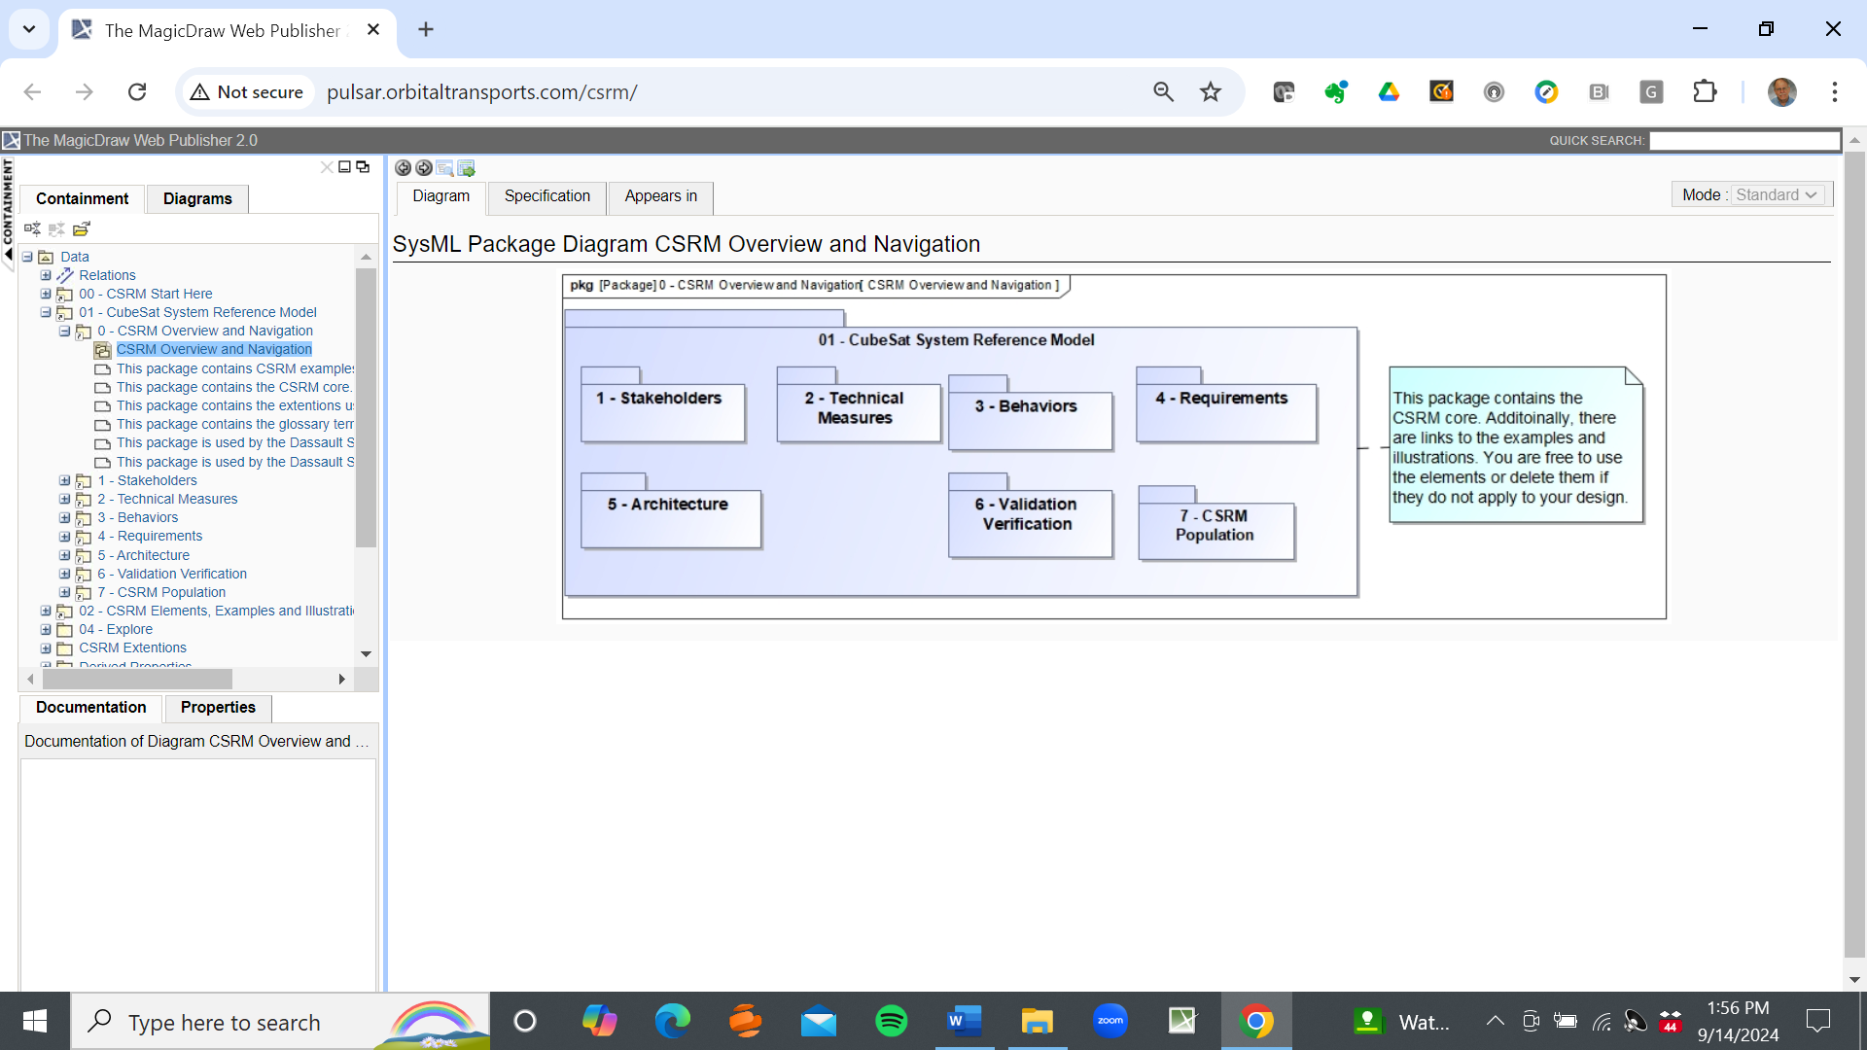
xx
Package Diagram 1. CSRM Overview and Navigation
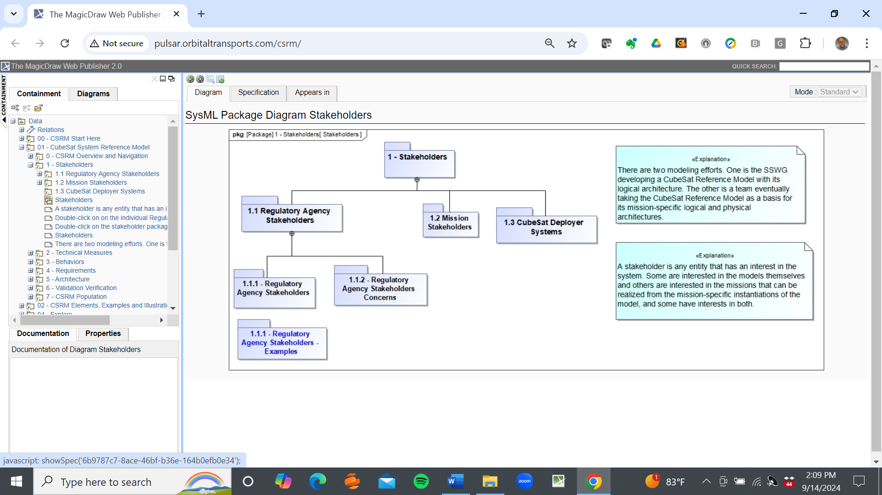
xx
Package Diagram 2. Stakeholders
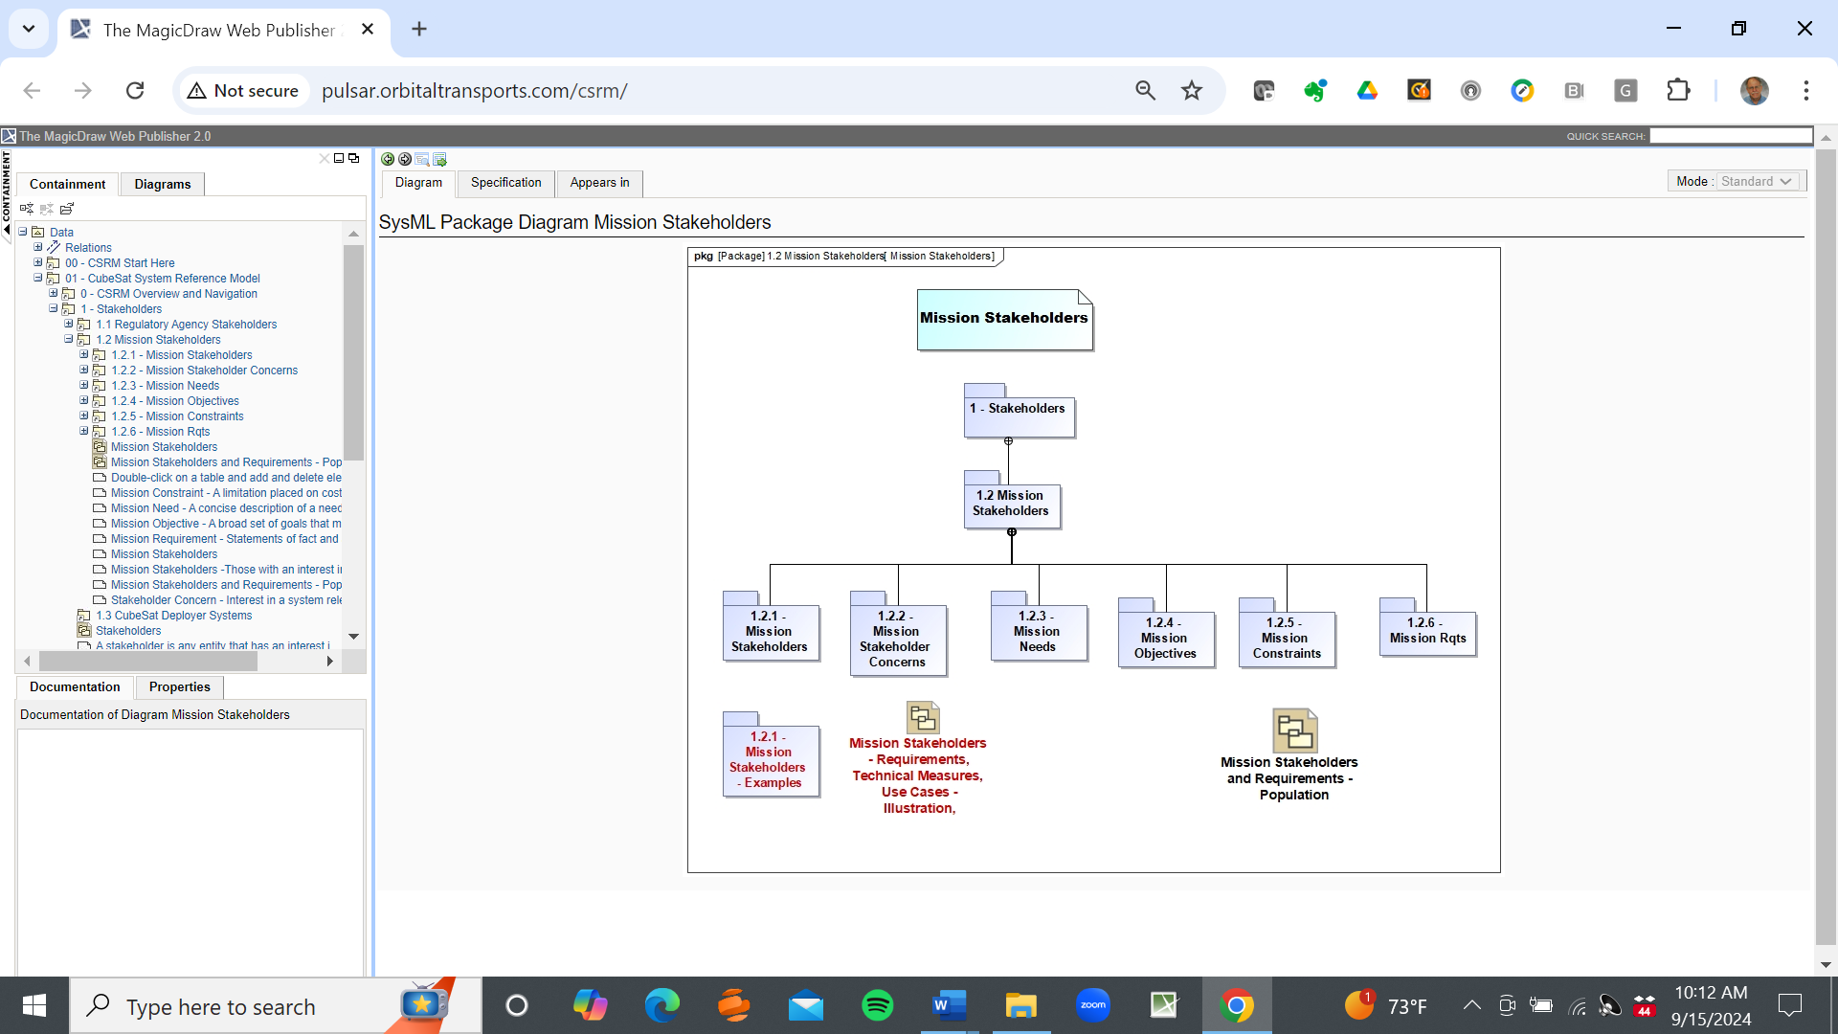
xx
Package Diagram 3. Mission Stakeholders
PD5
PD4
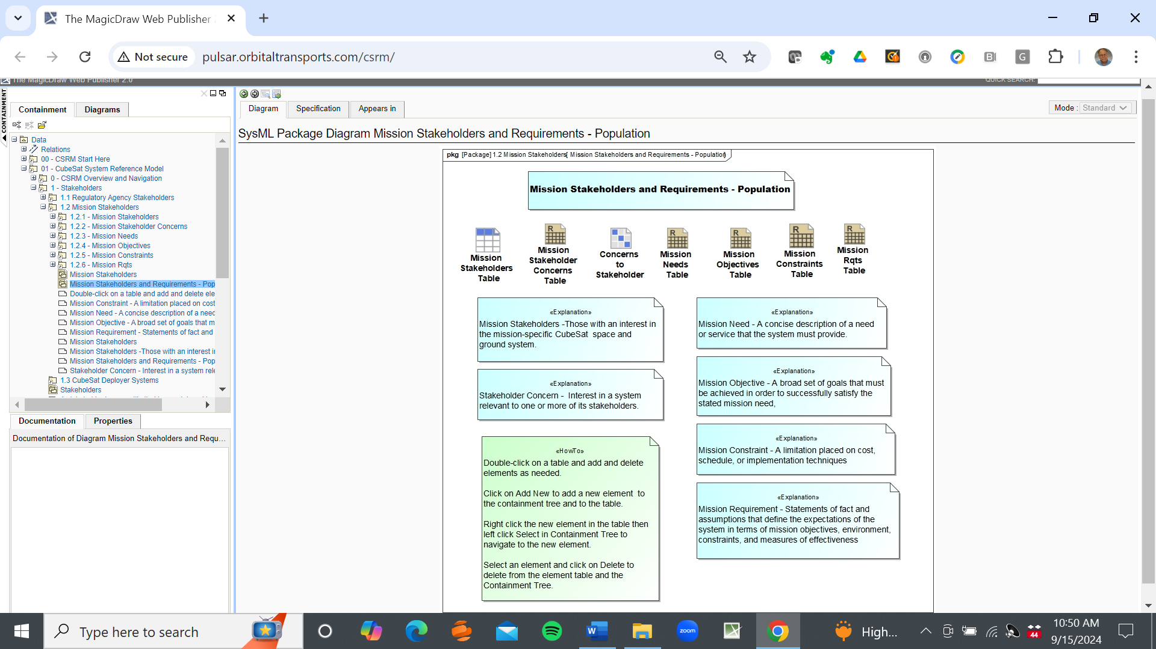
xx
Package Diagram 4. Mission Stakeholders and Requirements - Population
PD3
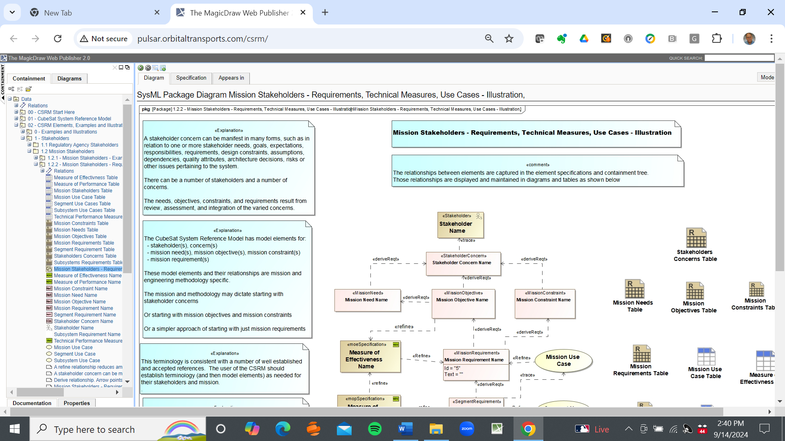
xx
Package Diagram 5. Mission Stakeholders - Requirements, Technical Measures, Use Cases - Illustration
PD3
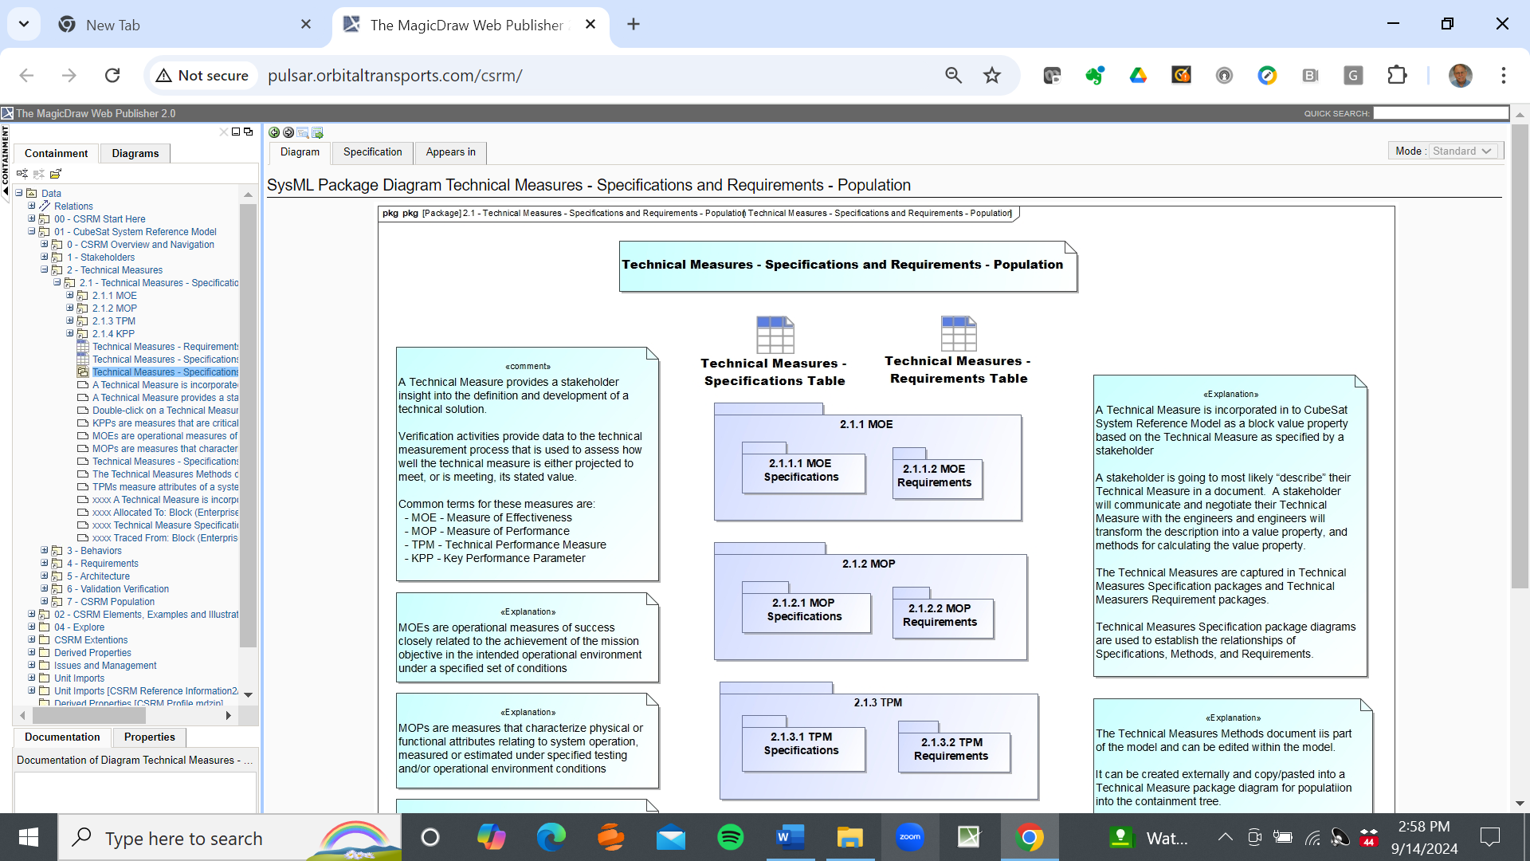
xx
Package Diagram 6. Technical Measures - Specifications and Requirements - Population
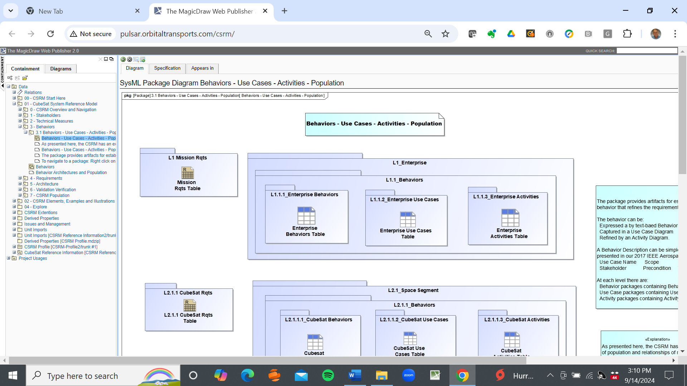
xx
Package Diagram 7. Behaviors - Use Cases - Activities - Population
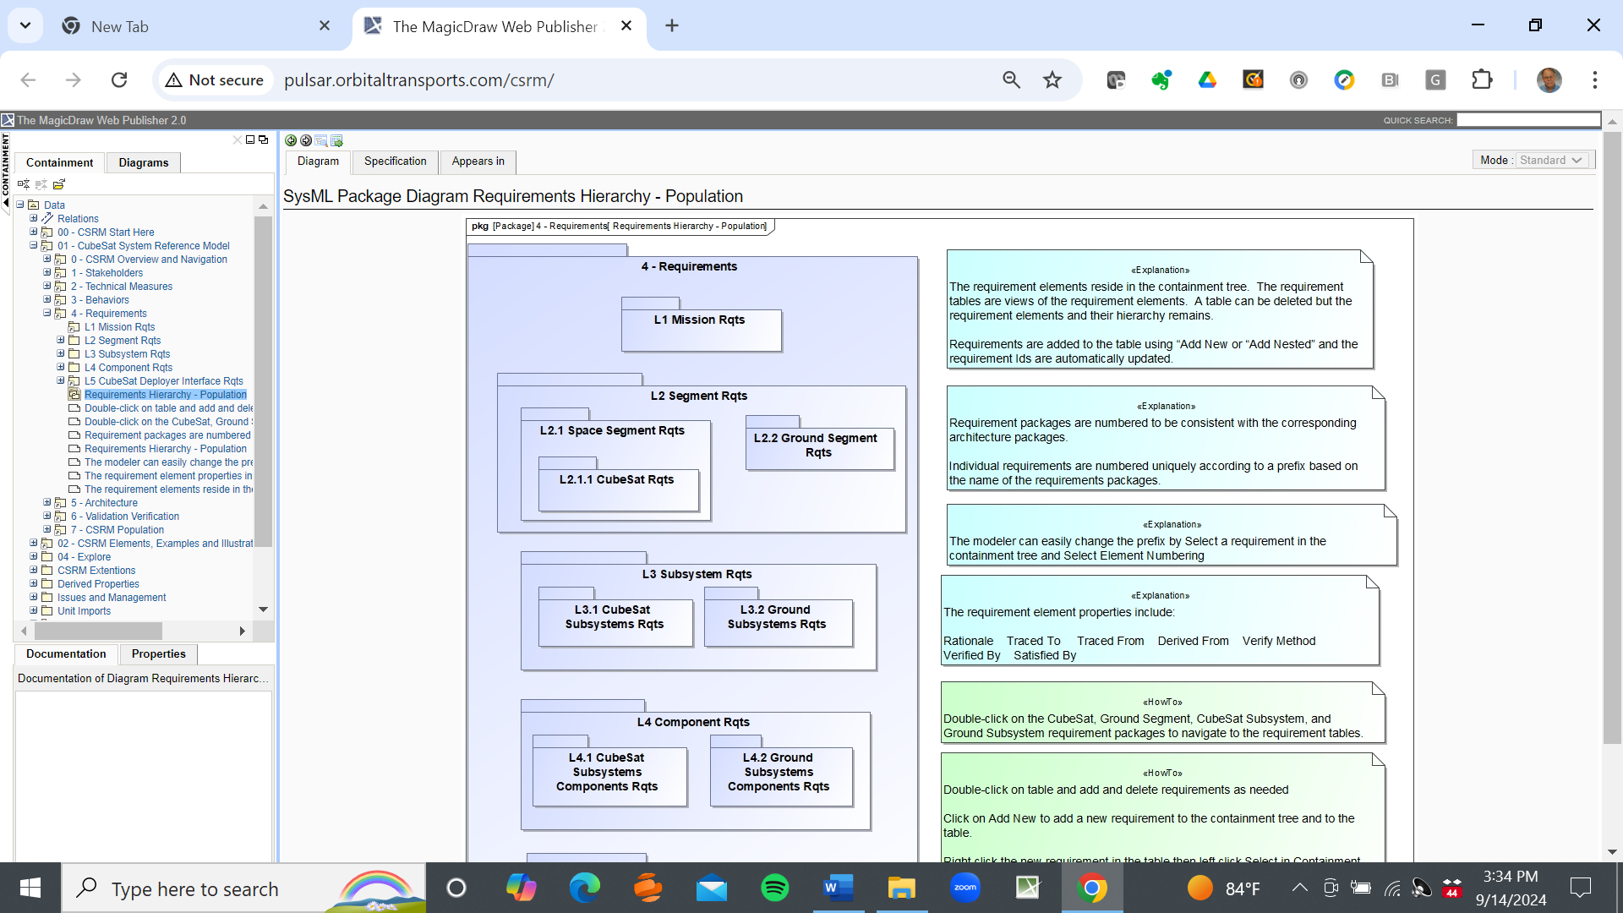
xx
Package Diagram 8. Requirements Hierarchy - Population
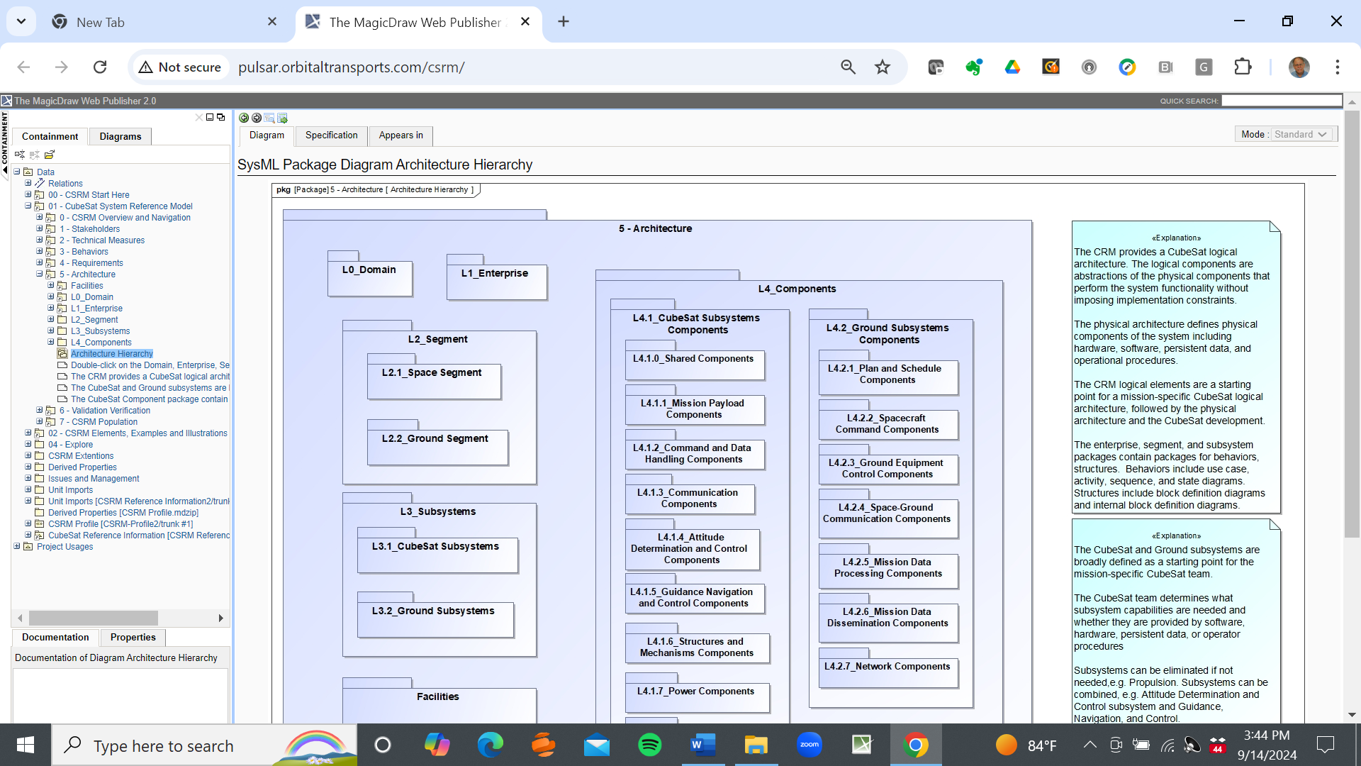
xx
Package Diagram 9. Architecture Hierarchy

