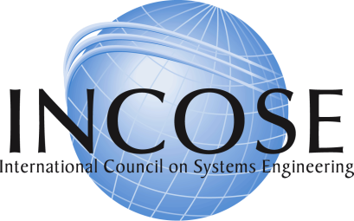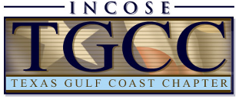
Call for Presentations: Systems Engineering in Aerospace and Oil & Gas – Opportunities for Collaboration
The art and science of Systems Engineering has been practiced within the Aerospace sector for many decades. While levels of maturity and specific practices vary significantly within Aerospace, the community possesses a wealth of experiences, lessons learned, and best practices. The O&G industry has also designed, built and operated systems of similar complexity to those in aerospace using different methods for system and information management. The Texas Gulf Coast Chapter of INCOSE is hosting a one day conference for the aerospace and oil and gas communities to share best practices.
This inaugural event will be held on May 5, 2017, and is titled: Systems Engineering in Aerospace and Oil & Gas – Opportunities for Collaboration. The conference provides a collaboration and communication opportunity for Systems Engineering practitioners in the Aerospace and Oil and Gas communities. The conference location is the Transocean Facility in Greenway Plaza (4 Greenway Plz, Houston, TX 77046).
The conference theme is “The business case for Systems Engineering: Complex systems in Aero and Oil and Gas - Compliance/Cost Savings/Reliability/Safety.”
We are seeking presentations related to this theme from both the Aero and O&G communities, specifically in the following areas:
- Success Stories in SE – supporting the business case for systems engineering. Presentations that provide insight into the benefits of SE in enhancing project execution success.
- Requirements development and management – lessons learned and best practices in the full range of requirements, from stakeholder initial involvement through detailed specification development and maintenance. Alignment with Industry standards and regulations.
- System Architecting – addressing approaches and methods for synthesizing, assessing, revising, and trading architectures during a system development or revision. Optimization for Operational Efficiency and Retrofit Applications.
- Test and Verification – presentations focused on the overarching process for ensuring the delivered system addresses ultimate user needs, and on the prototype, developmental, qualification, acceptance, or follow-on testing activities. Proving equivalence in function and performance with Industry standards and regulations.
- System Integrity – Functional Safety Integrity, Design for Maintainability and Reliability, Leveraging Model Based Engineering, Enhancing Usability via Human Factors

Format:
The format is presentation only, no papers required. Presentations will be scheduled in 30 minute time slots with 25 minutes for presentations and 5 minutes for Q&A. No proceedings will be published, although TGCC would like to post presentations to our internal web environment, with the permission of the authors. All presentations must be publically releasable.
Schedule:
- 1 Page abstracts due: February 15, 2017
- Presentations Selected: March 15, 2017
Interested presenters should submit their one page abstract to tgcc.incose@outlook.com.
For further information, please contact technical program chair Tony Williams at antony.g.williams@nasa.gov.

