Meeting Participants
Name | Company | Email | Attended
Lou Wheatcraft | Requirements Experts | LouW@Reqexperts.com | X
Mike Ryan | Univ of New South Wales | M.Ryan@adfa.edu.au | X

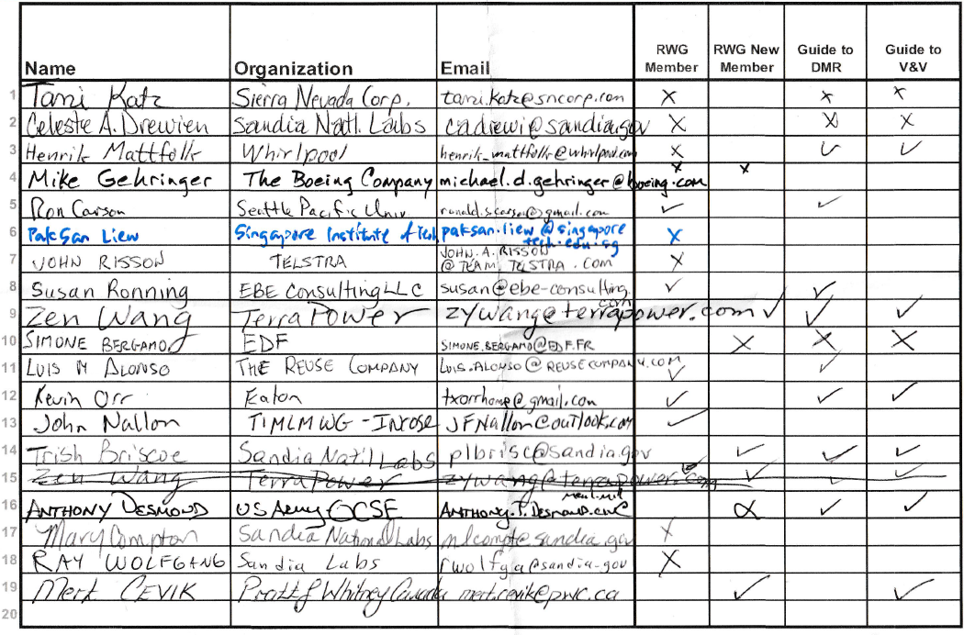

Agenda Lead
Subject Lead
- Overview of IW2019 Lou Wheatcraft
- Overview of RWG Activities in 2019/2020 Lou Wheatcraft/Tami Katz
- Updates to the Guide to Writing Reqts. Mike Ryan
- Status on the Guide to Dev and Manage Reqts Kevin Orr
- Status on the Guide to Verif. and Validation Tami Katz
- Overview of the Integrated Data paper Lou Wheatcraft
- Requirement Roundtable Q&A All
- Next Meeting Tami Katz

Overview of IW2019 Lou Wheatcraft
- Objective of IW2019: “The role of requirements in an MBSE world"
- RWG met 1/26/19 through 1/29/19, Lou shared charts discussing agenda, specific discussions
- Full sessions each day on various presentations from members concerning the role requirements play in a MBSE world
- 120 members participated
- Also discussed update to the Guide for Writing Requirements, and plans for two new guides: Developing and Managing Requirements, Guide for Verification and Validation

Plans for 2019/2020 Lou Wheatcraft/Tami Katz
Introduced Tami Katz as the new RWG Chair
Plans include:
- Maintain the RWG public and Connect web sites
- Support the SE Tools Database development efforts
- Support the update to the INCOSE SE Handbook
- Develop two new products: "Guide for Managing & Developing Requirements” and "Guide to Verification and Validation”
- Update the Guide for Writing Requirements Summary (4 pager)
- Provide RWG inputs into the SE Handbook vers 5 update
- Update current webinar-based training for the Guide for WR with new on-demand training
- IW2020
- Meet more regularly (virtually) to develop material and have RWG member collaboration

Updates to the Guide to Writing Reqts. Mike Ryan
- Went over changes from 2017 to 2019 Guide versions
- New examples
- Cleaned up editorial items
- Noted addition of 'concepts' in Figure 1, highlighting Transformation of concepts into needs into requirements

Status on Guide to Develop and Manage Requirements Kevin Orr
- Kevin Orr provided status on the Guide to Developing and Managing Requirements, showing outline, TPP, and next steps.
- Guide information is kept here: https://connect.incose.org/WorkingGroups/Requirements/GDMR/_layouts/15/start.aspx#/default.aspx

Status on Guide to Verification and Validation Lead
- Tami Katz provided status on the Guide to Verification and Validation, showing outline, draft, TPP, and next steps.
- Guide information is kept here: https://connect.incose.org/WorkingGroups/Requirements/Guide_to_VV/_layouts/15/start.aspx#/default.aspx

Presentation of Integrated Data as a Foundation of SE paper Lou Wheatcraft
- Lou presented the newly published Integrated Data paper as well as some key insights obtained during the IW2019 discussions

Roundtable Q&D All
- RWG members posed various questions for discussion and help.

Next Meeting Tami Katz
- The next in person meeting is at IW2020 in Torrance, CA.
- Tami will set IW2020 agenda in December and distribute to RWG.
- Tami will also set up virtual meetings between IS2019 and IW2020 to allow membership participation for those that cannot travel in person

