# Highlights Guide to V&V Notes IW2021, 1-26-21

Beth Wilson - can we also align with competency framework?

Rick Hefner - verification is to verify something against criteria; is this still the concepts, how do requirement verification work in this construct?

Raymond - Showed the Design and System V&V chart, appeared to be missing a verification loop from design input requirements to stakeholder needs Rick Zinni noted this may not be credible, does not seem to see the case we would verify need statements

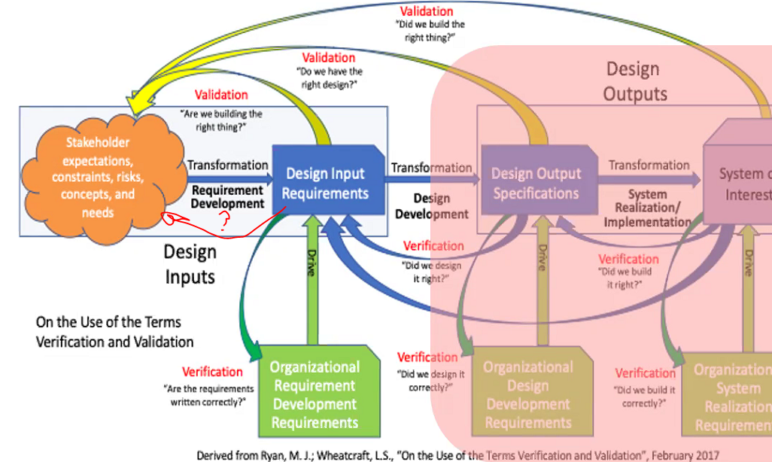

**To circle back** - are we advocating a "Needs Verification" action?

Francesco - We should always respect the stakeholders and people we need to address; validation is always reflective against the needs and expectations;

Mike Pafford: The NEEDS area is where I have been concentrating my research and work. Shameless plug for my session on Sunday January 31st 1pm-3pm EST. That Tutorial is specifically about an Approach currently being used to address the Needs part of the life cycle, in Initial Project Planning. As it matures, I plan to integrate my Initial Project Planning (i.e., Needs) work into several other WG initiatives.

Lou - this is an old diagram, has been updated.

**To circle back** - let's ensure our RWG products use the latest and greatest material/diagrams.

Beth - checking outline, like the content recommended, looking forward to going through the manual. Resonant with connect between requirements and verification; frustration as a test director was the reqts team were writing reqts where the audience was design, was often in their face as this is a contract for test and a recipe for design;

Tami - it will be interesting to set the nomenclature paradigm change for requirement verification vs system verification in this material rollout and discussions.

Leardi Carlo - There is the opportunity to challenge the guidelines vs.(in?) real system development during reviewing time. This could be a relevant contribution. Will the guide be useful for the general engineer to address their questions question is "I have an issue, do I find help/guidance on the how in the guidelines?"; Most useful to convey the concepts: examples, tables, figures/graphs

Leardi - ensure guideline is chart and information is easy to find.

Beth - keep examples, but not overly complicated or distracting, don't go too specific to a domain; example she uses is 'need my jeans to fit better', decomposes to requirements on fitness, diet etc. Then validate results against the needs by "will this help me achieve better fitting jeans?". Relatable examples. Coffee as the example as a thread throughout can work. Student vs practitioner, competency model deltas, guide addresses each of these roles of different competency. Training more experienced practitioners would get more complicated examples in training. Keep examples to illustrate concepts.

Mike Pafford: In my classes, I always Started with the old faithful analogy: Verification = "Are we engineering the system right? (according to Specs). And Validation = "Are we engineering the right system? (according to Customers/Users)" I go into specifics after the students fully understand those two simple concepts.

**To circle back** - Raymond concerned on use of "product verification", we can ensure common term usage across manual/guides here

Paul Davies - Should the definition of terms be in alphabetical order?

**To circle back** - how much nomenclature in Guide vs Manual?

**To circle back** - Details of N/R V&V in other Guide, we can need to work pointers

Don McNally - Rather than a reference, a direct link would facilitate usability

Paul Davies - …and (Don) consistency when changes occur

Me - data focused vs doc focused guide/manual is great, how feasible is this for INCOSE releases?

James Vita - methods should break out simulation as a method I feel

James Baker - Where does the accreditation of the simulation fit? Accreditation: "The official certification that a model, simulation, or federation of models and simulations and its associated data are acceptable for use for a specific purpose."

James Vita - risks need mitigation methods and could tie to V&V, would be good to have a mention of this.

Lou - in the lifecycle concept in manual - there is treatment of risk mitigation, and reflected in needs/requirements, and associated attribute with a requirement that addresses risk mitigation.

Mike Pafford - If everyone doesn't mind, even before Simulation in IV&V, there will in reality be the question of using Modeling in IV&V. Maybe it'll be addressed as M&S together. But, I think we all already are seeing the question about using Modeling in IV&V.

Lou - The new text for the SE HB addresses model verification and validation. ; The manual states that all models and simulations must be verified and validated before use

**To circle back** - do we need to discuss approaches for simulation as a V&V method, and any logistics?

Publishing note from Beth Wilson - Another consideration is making sure the work products are accessible to people with low vision. That means alt-text for all graphics and making sure the formatting translates properly to text to voice tools. On accessibility, I have some industry guidelines from an accessibility project from last year. I can help with this -- I'm not just assigning homework (smile).