INCOSE International Workshop 2024
System of Systems Working Group Report

Overview:

The SoS WG held two sessions at INCOSE IW 2024. The presentation materials from these sessions are available at: [https://www.incose.org/inet/working-groups/systems-of-systems]

- Sunday, January 28 - 1-3: Working session on approaches to SoS Engineering

The current SEBOK SoS knowledge area focuses on broad discussion of systems of systems (SoS) characteristics and systems of systems (SoS) challenges. When we look at progress which has been made in the last few years, it is time for a revision and a new focus on approaches to addressing SoS. This session provided a venue for SoSWG members to share approaches they have implemented, and their lessons learned. The results of this session will provide input to the update of the SEBOK.

- Monday, January 29: 9:30-12: SoSWG Business Meeting

This meeting reviewed the status and plans for current activities of the SoSWG and open discussion of possible new initiatives.

This report summarizes the discussions at these two sessions and follow-up actions. There was active participation in both session with ~40 in-person and remote participants in each session.

- Monthly Webinars

The SoS WG has sponsored monthly online webinars since the WG was first created. These are recorded and posted on SoS WG Connect Site at:

https://connect.incose.org/WorkingGroups/SystemofSystems/SAWG%20Shared%20Documents/Forms/AllItems.aspx?RootFolder=/WorkingGroups/SystemofSystems/SAWG%20Shared%20Documents/Webinars

The webinar lead, Jason Sherey, requested recommendations for presentations.

Action: Contact Jason at jasonsherey@gmail.com with recommendations for SoS Webinar presentations.

- Upcoming Conferences
There are three notable events on the horizon offering good SoS opportunities.
- 2024 IEEE SYSCON in Vancouver, British Columbia on 17-20 April 2024. https://2024.ieeesyscon.org/

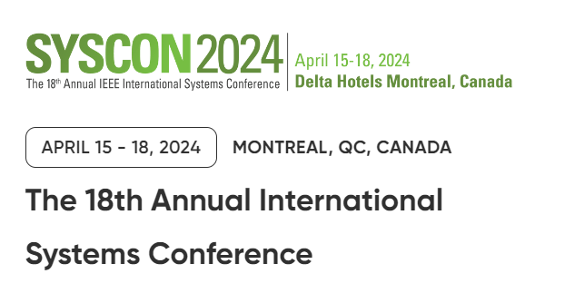

- INCOSE International Symposium 24 in Dublin, Ireland on 2-6 July 2024. https://www.incose.org/symp2024

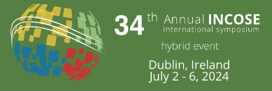

- 19th Annual Systems of Systems Engineering (SoSE) Conference, in Tacoma Washington, June 23-26, 2024. https://sosengineering.org/2024/
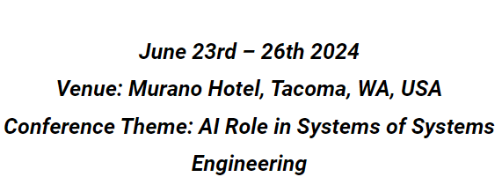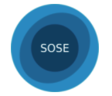

INCOSE is a partner in the SoSE conference. In 2023, at the conference held in Lille France, the INCOSE – SOSE Conference partnership MOU was signed. At the 2023 conference, we hosted a panel entitled “SoS Pain Points a 10-year retrospective”. Garry Roedler chaired the panel with Alan Harding, Judith Dahmann and Jakob Axelsson as panelists. Alan Harding also gave a Keynote address entitled “Insights from a career in the development and evolution of Systems (of Systems)”.

INCOSE will offer a panel at the 2024 SoSE on “The Impact of Advanced Technologies on SoSE”, and three INCOSE Keynote addresses are planned: Marilee Wheaton -- INCOSE Past President, Sky Matthews – IBM, and John Palmer – Boeing.

The closing date for paper submissions is 1 April 2024, information is available at https://sosengineering.org/2024/.

- INCOSE Handbook

The INCOSE SE Handbook 5th Edition was released in July 2023. The SoS section was provided by the SoSWG. Beth Wilson noted that the INCOSE certification exam includes SoS.

- Engagement with Other WGs

The nature of SoS which are present in almost all domains and which employ SE processes adapted to the characteristics of SoS mean that there is an opportunity for the SoSWG to work cooperatively with the INCOSE working groups focused on domains and SE processes.

- Complexity Working Group: The SoSWG has had an ongoing relationship with the complexity working group.
  - The SoS and Complexity collaboration resulted in an article published this year in the SEBOK Emerging Technologies Knowledge Area https://sebokwiki.org/wiki/System_of_Systems_and_Complexity
  - In the Sunday SoSWG session on SoSE Implementation approaches, one suggestion was to review the recent update of the Complexity Primer for added information on ways to address SoS complexity challenges identified in the prior SoS/complexity collaboration.

- Systems Security Working Group:
  - At Tech Ops request, Beth Wilson developed a part on “System of Systems (SoS) Perspective on SE for Cyber Contested Environment”. This paper is available at [https://www.incose.org/inet/working-groups/systems-of-systems].

- Requirements Working Group:
  - At the last IW, the working group decided to undertake a new line of effort, to provide an SoS perspective on INCOSE products. The first products to be looked at are those of the Requirements WG.
  - Based on a review of the recently issued Needs and Requirements Manual (NRM) and its offshoot guides to writing requirements and to needs and requirements Beth Wilson proposed that instead of a standalone derivative guide, the most effective approach will be to create a translation guide for SoS readers/users of the RWG products.
  - Following an approach used for system security, Beth Wilson agreed to develop a Guide to SoS Needs and Requirements.
Action: If you are interested to engage in review of the RWG products, contact Beth Wilson wilsondrbeth@aol.com.

- Working Group Roundtable hosted by SoSWG:
  - In addition to these specific working group engagements, the idea was raised of holding a SoS working group roundtable and inviting other working groups to engage in a discussion of the relationship of SoS to their areas of interest. This approach was used by the Systems Security working group several years ago with success and the Infrastructure Working Group is hosting a session with this object at this IW. Both working groups could provide advice based on their experiences.
Action: Dahmann and Harding to explore hosting an online working group roundtable. Please jdahmann@itre.org and alandharding@gmail.com if you are interested to support this activity.

- Relationship between SoS, Capability Engineering, Mission Engineering & Complexity
  - The idea of an initiative in this area was raised at the last two IWs but no action resulted. Since there appears to still be interest in the topic, we will continue to track possible SoSWG activity.
Action: Contact jdahmann@mitre.org if you are interested in engaging in an initiative in this area.

- Heuristics
  - INCOSE has an ongoing initiative to develop and share systems engineering heuristics. There is an opportunity for the SoSWG to participate and provide an input from SoS perspective.

Action: Contact jdahmann@mitre.org and alandharding@gmail.com if you are interested in engaging in an initiative in this area.

- SoSE Implementation Approaches – SEBOK SoS Knowledge Area Update
As noted above, a working session was held at IW24 to address current SoSE implementation approaches as input to a proposed update of the SEBOK SoS Knowledge Area (KA) https://sebokwiki.org/wiki/Systems_of_Systems_(SoS). The results of this session were reviewed at the SoSWG business meeting. The materials from the working session can be accessed here [https://www.incose.org/inet/working-groups/systems-of-systems].

By way of background, the SoSWG is a steward for the SoS KA. Michael Henshaw and Judith Dahmann serve as editors of the SoS KA and Tom McDermott is the editor of SEBOK Part 4 – Applications of SE, where the SoS KA resides. Since the initial publication of the SEBOK, the original structure or the KA has not changed, and the updates have been incremental changes to the original materials.

The current SEBOK SoS knowledge area focuses on broad discussion of systems of systems (SoS) characteristics and systems of systems (SoS) challenges. While these basic discussions about SoS are useful, these sections would benefit from a refresh. And given the progress made in the last few years, we recommend a restructuring and revision of the KA to focus more on approaches to addressing these challenges.

Based on this working session where there was great participation (~40 in-person and remote participants) and lively discussion, the group found good opportunities in the approaches included in the meeting discussion slides:

- Leverage/update some longstanding approaches (based on approaches described in Cook and Unewisse, 2020 and wave model in Dahmann 2011)
- Build on emerging complexity materials (e.g. SoS and Complexity in SEBOK Emerging Technologies and most recent Complexity Primer)
- SoS approached to apply data analytic methods for understanding SoS performance (Purdue SoS Workbench and Missouri Meta Architectures, in Verma edited volume on Systems Engineering in the Digital Age, 2024)
- Address issues beyond technical (Yokell, 2021 and Henshaw, 2015)
- Mission engineering - relevant but needs to be translated to non-Defense language (Dahmann, 2023)

The group also identified additional near and long-term areas to be incorporated into the SoS KA:
- Multi-Scale (socio technical) SoS
- Innovation Systems/ SoS
- Methods from specific domains (e.g. Rail, Energy, Medical devices)
- Ultra-Large – Mega Systems

There was interest on the part of participants for more information about available tools developed to support SoS analysis – particularly the Purdue SoS Analytic Workbench and the Missouri SoS EXPLORER.

Action: Judith and Alan to work with …. to collect and share information on their tools.
- Dan Delaurentis ddelaure@purdue.edu and Cesare Guariniello cguarini@purdue.edu (SoS Analytic Workbench)
- Cihan Dagli dagli@mst.edu (SoS EXPLORER)

Finally, there was a strong support to include discussion of ‘enablers’ which are important for different approaches, possibly important non-technical preconditions for success application of SE to SoS. Since there does not appear to be readily available literature on this topic, it was suggested that the SoSWG convene an online session to explore this area.

Action: Contact jdahmann@mitre.org and alandharding@gmail.com if you are interested in engaging in planning and conducting a session on SoSE enablers; Judith and Alan to propose an online session to address this topic.
Next steps - Actions:
- Michael Henshaw and Judith Dahmann to review discussion to propose and develop near-term SEBOK updates and share these with SoSWG for input and participation.
- Tom McDermott develop article on Innovation Systems of Systems
- Tom McDermott to contact potential author for article on Data Analytic Methods and coordinate exchange with Micheal and Judith and author on this article.

Summary of Actions:

- Action: Contact Jason at jasonsherey@gmail.com with offers or recommendations for SoS Webinar presentations.
- Action: If you are interested to engage in review of the RWG products, contact Beth Wilson wilsondrbeth@aol.com.
- Action: Dahmann and Harding to explore hosting an online working group roundtable. Please jdahmann@itre.org and alandharding@gmail.com if you are interested to support this activity.
- Action: Contact jdahmann@mitre.org if you are interested in engaging in an initiative in this area.
- Action: Contact jdahmann@mitre.org and alandharding@gmail.com if you are interested in engaging in an initiative in the area of Heuristics.
- Action: Judith and Alan to work with …. to collect and share information on their tools.
  - Dan Delaurentis ddelaure@purdue.edu and Cesare Guariniello cguarini@purdue.edu (SoS Analytic Workbench)
  - Cihan Dagli dagli@mst.edu (SoS EXPLORER)
- Action: Contact jdahmann@mitre.org and alandharding@gmail.com if you are interested in engaging in planning and conducting a session on SoSE enablers; Judith and Alan to propose an online session to address this topic.
- Actions:
- Michael Henshaw and Judith Dahmann to review discussion to propose and develop near-term SEBOK updates and share these with SoSWG for input and participation.
- Tom McDermott develop article on Innovation Systems of Systems
- Tom McDermott to contact potential author for article on Data Analytic Methods and coordinate exchange with Micheal and Judith and author on this article.

