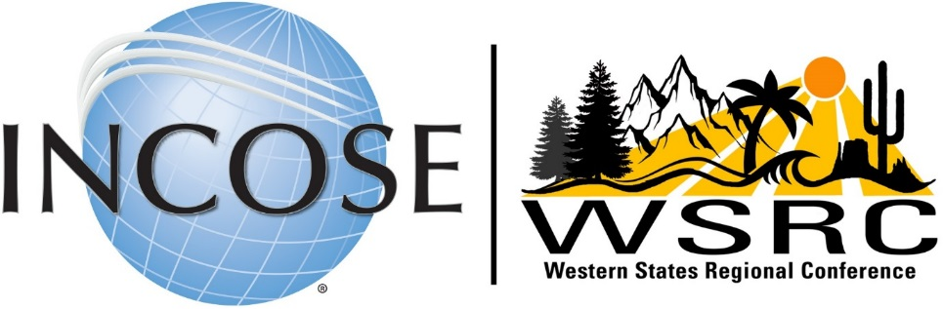

Save the Date: September 19-21, 2024

Albuquerque, New Mexico

**Call for Sponsors**

The INCOSE western regional chapters will host our seventh annual Western States Regional Conference (WSRC) Thursday through Saturday, September 19-21, in Albuquerque, New Mexico, at the Central New Mexico Workforce Training Center.

This 3-day event will feature keynote and technical presentations about systems engineering (SE) from thought leaders, working groups, and chapter leader meetings, panel discussions, and networking events and activities.

The WSRC will provide superb opportunities to showcase your products and services. We expect on-site attendees—plus more remotely—from aerospace, defense, energy, government, agriculture, automotive, biomedical & healthcare, education, information, infrastructure, safety and security, space, and transportation. These attendees will be key decision-makers and systems engineers—the target market for your products and services.

We appreciate your help in sharing the usefulness and impact this conference brings. We expect to reach an untapped market of end users and companies who are just learning the benefits of applying systems engineering to their industries and domains.

We invite your organization to participate as a sponsor in this regional event. Your sponsorship of the WSRC will be rewarded with multiple acknowledgments and benefits, as identified on the other side of this sheet. In addition, if you will tell us your needs and preferences, we can tailor sponsor benefits to suit.

**INCOSE WSRC Sponsorship Levels for Organizations**

|  |  |  |  |  |  |  |  |  |
| --- | --- | --- | --- | --- | --- | --- | --- | --- |
| **Sponsorship Levels** | **Educator or Nonprofit** | **Basic for Profit** | **Professional Society** | **Patron** | **Bronze** | **Silver** | **Gold** | **Platinum** |
| **$250** | **$500** | **$750** | **$1,000** | **$1,500** | **$2,500** | **$3,500** | **$5,000** |
| Logo on Conference Program Booklet | X | X | X | X | X | X | X | X |
| Logo on Conference Website | X | X | X | X | X | X | X | X |
| May Insert Item into Conference Tote Bag |  | X | X | X | X | X | X | X |
| Shared (half) Display Table [skirted, 1 chair] |  |  | X | X |  |  |  |  |
| Exhibit Table(s) [skirted, 2 chairs] |  |  |  |  | 1 | 1 | 2 | 2 |
| Conference On-site(s) (conference fee only) |  |  |  |  | 1 | 2 | 3 | 4 |
| Registrant List (with contact info) before conference |  |  |  |  | X | X | X | X |
| Attendee List (with contact info) after conference |  |  |  |  | X | X | X | X |
| Break Sponsor |  |  |  |  | X |  |  |  |
| Reception/Breakfast Sponsor |  |  |  |  |  | X |  |  |
| Lunch Sponsor |  |  |  |  |  |  | X |  |
| Banquet Sponsor |  |  |  |  |  |  |  | X |
| Full-Page Advertisement in Program Booklet |  |  |  |  |  |  |  | X |
| Address to Attendees at Banquet (5 minutes or less) |  |  |  |  |  |  |  | X |

NOTES:

* For-profit organizations should select the Basic, Patron, Bronze, or higher levels.
* Professional societies should select the Professional Society level.
* Educational or non-profit organizations should select the Educator or Nonprofit level.

Tell us your needs and preferences. We can tailor sponsor benefits to suit!

**You can register for all sponsorship levels at this** [**link**](https://www.eventbrite.com/e/western-states-regional-conference-2024-sponsors-tickets-840873113117)**.**

**Visit our WSRC 2024 website at this** [**link**](https://www.incose.org/events/2024-wsrc)**.**

For questions or comments, please contact WSRC Sponsorship and Exhibits Chair: Paul Kostek at [pjkostek@gmail.com](mailto:pjkostek@gmail.com) or Raymond Wolfgang at [rwolfga@sandia.gov](mailto:rwolfga@sandia.gov).